San Luis Yacht Club Chase Boat

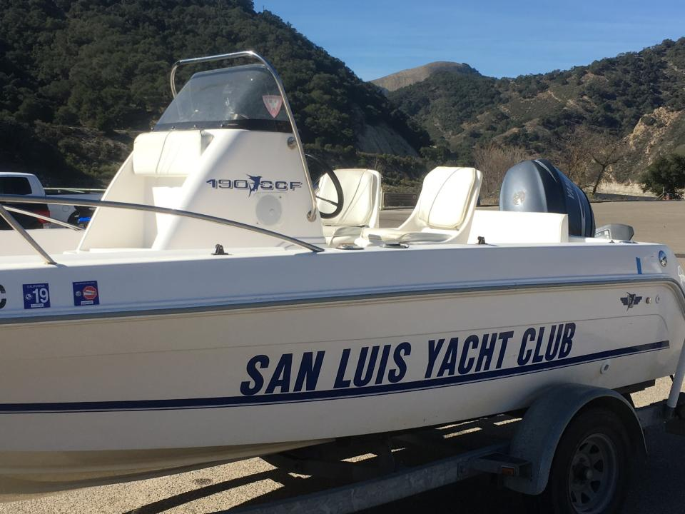

Information Manual
January 24, 2019

Chase Boat Storage:
The address to the boat storage yard is 2100 Creek Road, Oceano, CA. It is basically across the street from the Melodrama down a dirt road. If you search the address on Google Maps, you will get you close. I have attached a Google Map with an arrow showing the actual gate location down the dirt road.

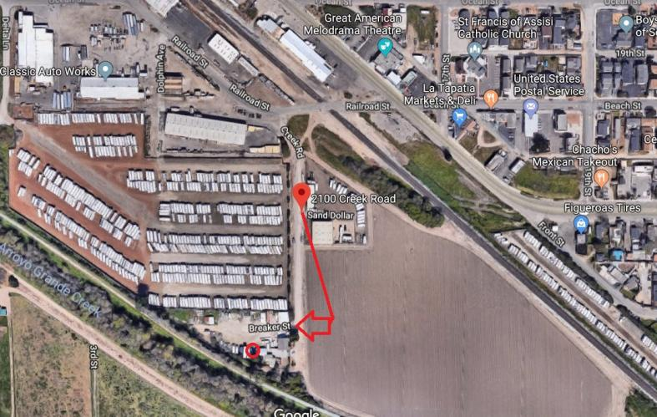

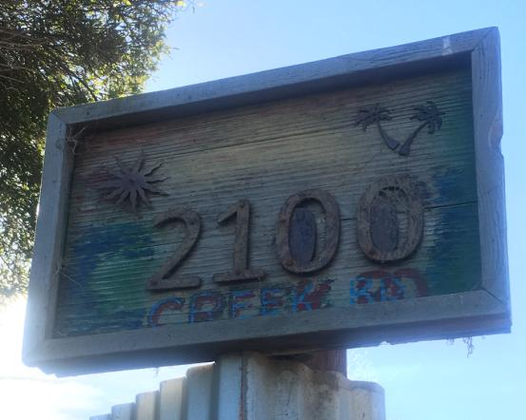

Gate Combination Key Lock Boxes:
The code for gate SLYC Key lock box is (on top, Kiddie brand): 076
Inside you will find a key to open the padlock on the gate.

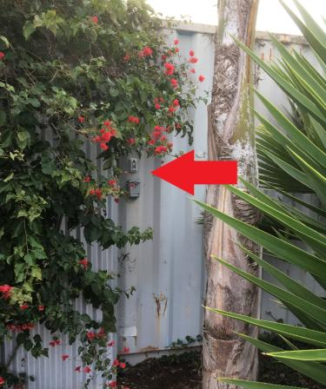

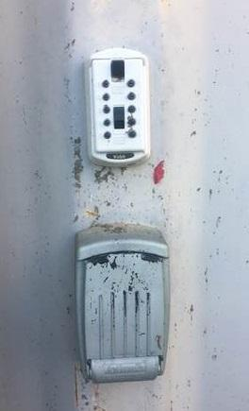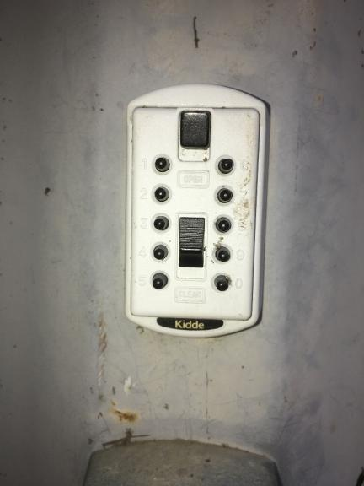

The code for gate Owners lock box is (on bottom): *357
*Note: We only used this when the lock was changed and we didn’t have the new key in the SLYC lock box.
Storage Shed:

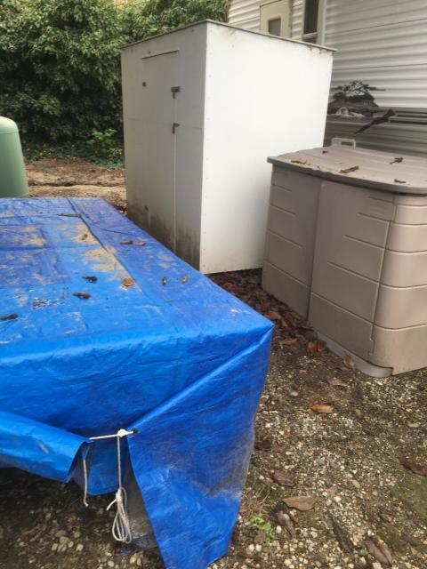

The code for the storage shed is: 7676 (numbers align up on the side)

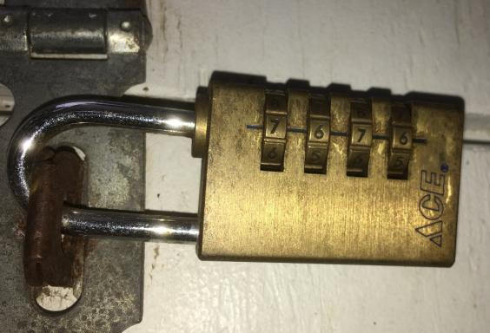
Chase Boat Marks/Anchors Inventory (2/2018)
Inventory list with photos taken in January 2018.

3 orange tetrahedron marks and each has a Danforth anchor with chain/rode.

1 large red buoy
1 medium red buoy
1 medium faded red buoy

1 mushroom anchor
Spare rode on spool

2 warming blankets

Life jackets / PFDs

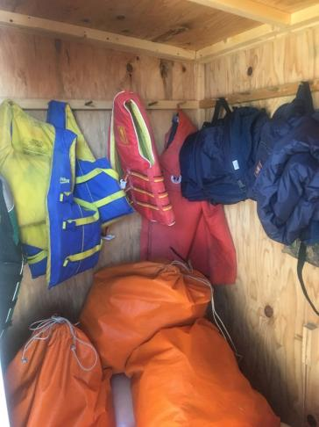
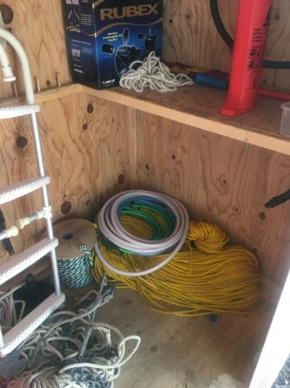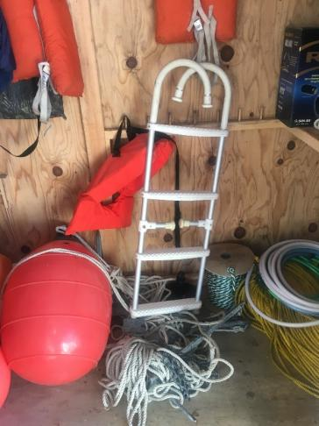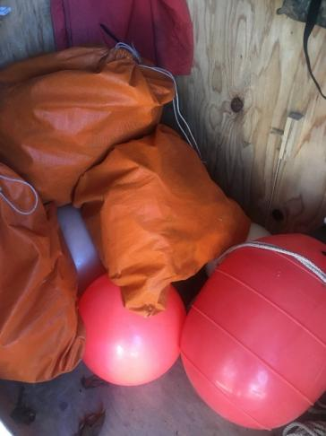
Chase Boat Keys & Red Bag:
In the orange bucket is that red bag that contains the Chase boat keys, keys to the trailer hitch lock and spare tire key and boat plug. It also contains the trailer jack.

There is a spare set of Chase boat keys in the console of the boat in the plastic box with a green cover.

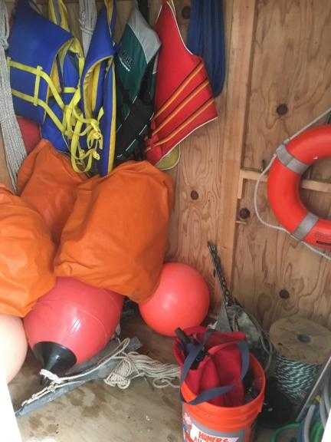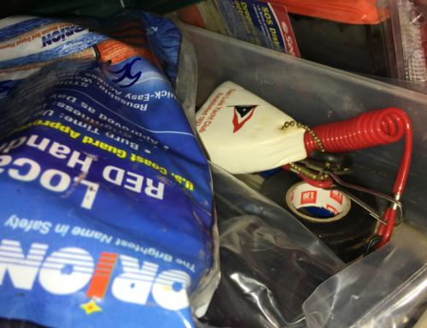

Typical Boat Day for Ocean Races:
Meet at the Oceano Boat storage, take off the boat cover, load up the gear from the storage shed into the boat, get over to Port San Luis and launch the Chase boat around 10 am, taxi passengers out to their boats, while the boats are getting ready we set the marks, races start at noon or earlier if the boats/marks are ready sooner, follow the boats around for 3 or maybe 4 races / last race ends by 3 pm, pick up the marks unneeded for the last race around 2 pm/2:30 pm, pickup all marks at the end, taxi passengers back to the launch and get the boat out of the water before 4 pm, flush the boat motor at Port San Luis and take the boat & gear back to Oceano storage.

Chase Boat Captains:

Jim Gilletly
Rod Valine
Bill Dryer
Barry Stewart
John Stocksdale
Dave Lipanovich
Mike Davis

Foghorn Articles:
You are encouraged to write a Power Captain article for the Foghorn newsletter. You can submit articles to Donna Ellison (donnaellisonduffy@gmail.com) by the 20th of the month. When possible I tried to take a photo while on the water or enlist others to provide photos of the Chase Boat and include them with the article. I sometimes ask Michael Dobrzensky if he took any Chase Boat photos when he’s been around during the races. It’s nice to say thanks the Chase Boat Captain & Crew for helping out. You might also share your experiences, boating safety information or other related information.

Lopez Lake Mussel Tag:
Lopez Lake requires that you get a mussel inspection or maintain a mussel tag. Last year the rangers was very friendly, but you do need to allow for a 15 minute inspection the beginning of the season. Be sure to remove all water from the bilge, upper bow storage and lower bow storage compartments using a towel. Before you leave the lake each time, you just stop by the ranger office and request a mussel tag.

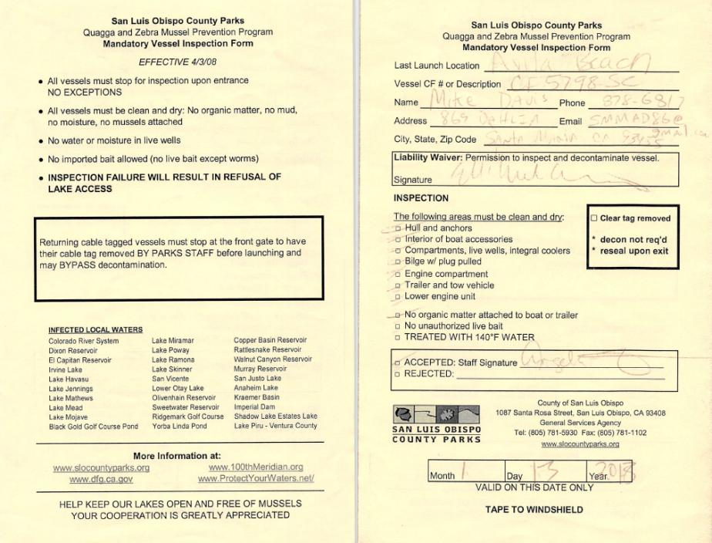

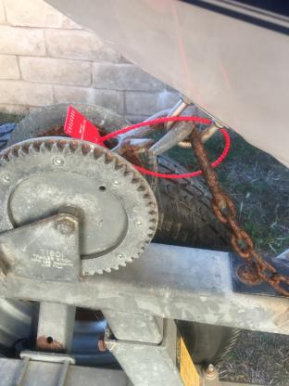
Boat Registration:
There is a copy of the boat registration in the Chase Boat console.

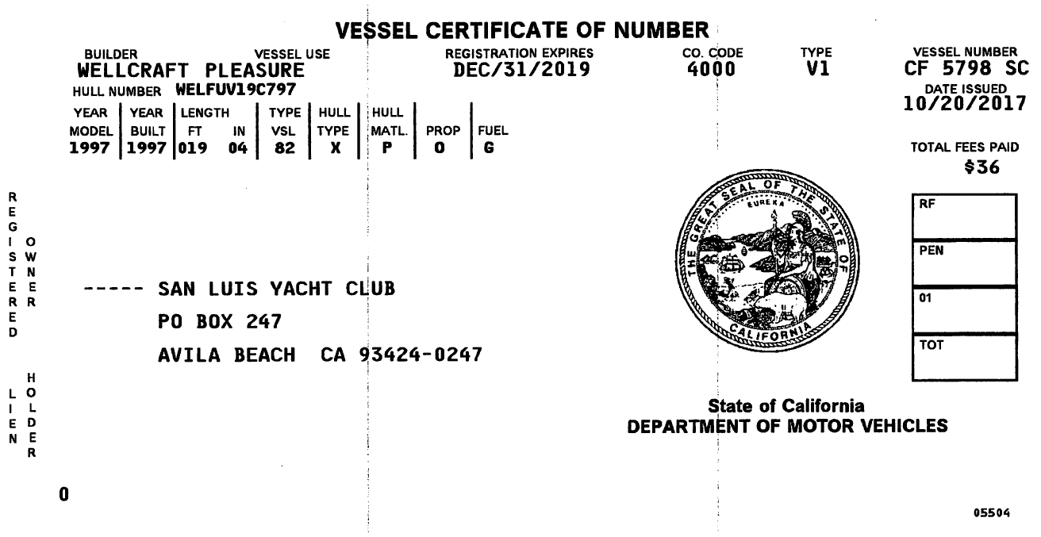

Boat Trailer Registration
There is a copy of the boat trailer registration in the Chase Boat console.

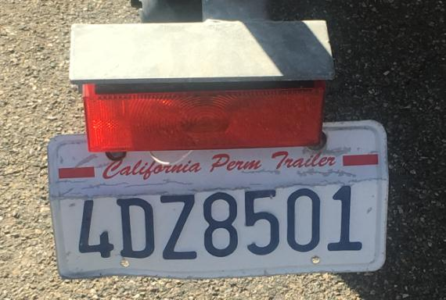
Chase Boat Capacities:

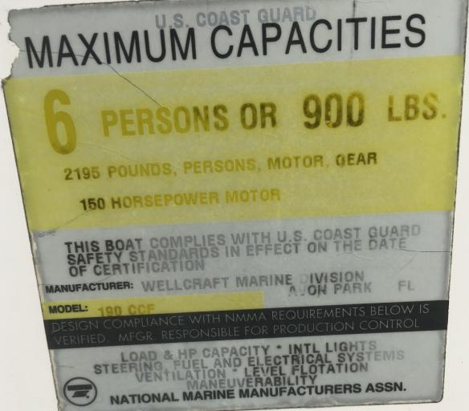

Coast Guard Vessel Safety Check/Decal:
In 2018, I was able to have the SLYC Chase Boat inspected by the United States Coat Guard Auxiliary during the May 20th Port San Luis Safe Boating Day event. The Auxiliary performed a free Vessel Safety Check (VSC) of the boat‘s systems and safety equipment. I’m happy to report we passed and the SLYC Chase Boat was issued a 2018 decal. There is no cost for this service which only takes about 20 minutes and the decal informs the Harbor Patrol, Coast Guard, Sheriff and other law-enforcement that you are in full compliance with Federal and State boating laws. For more information see their website: http://cgaux.org/vsc.

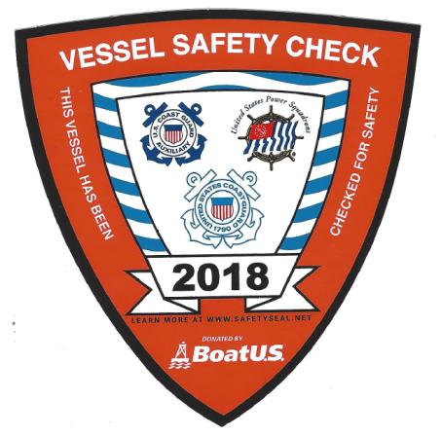

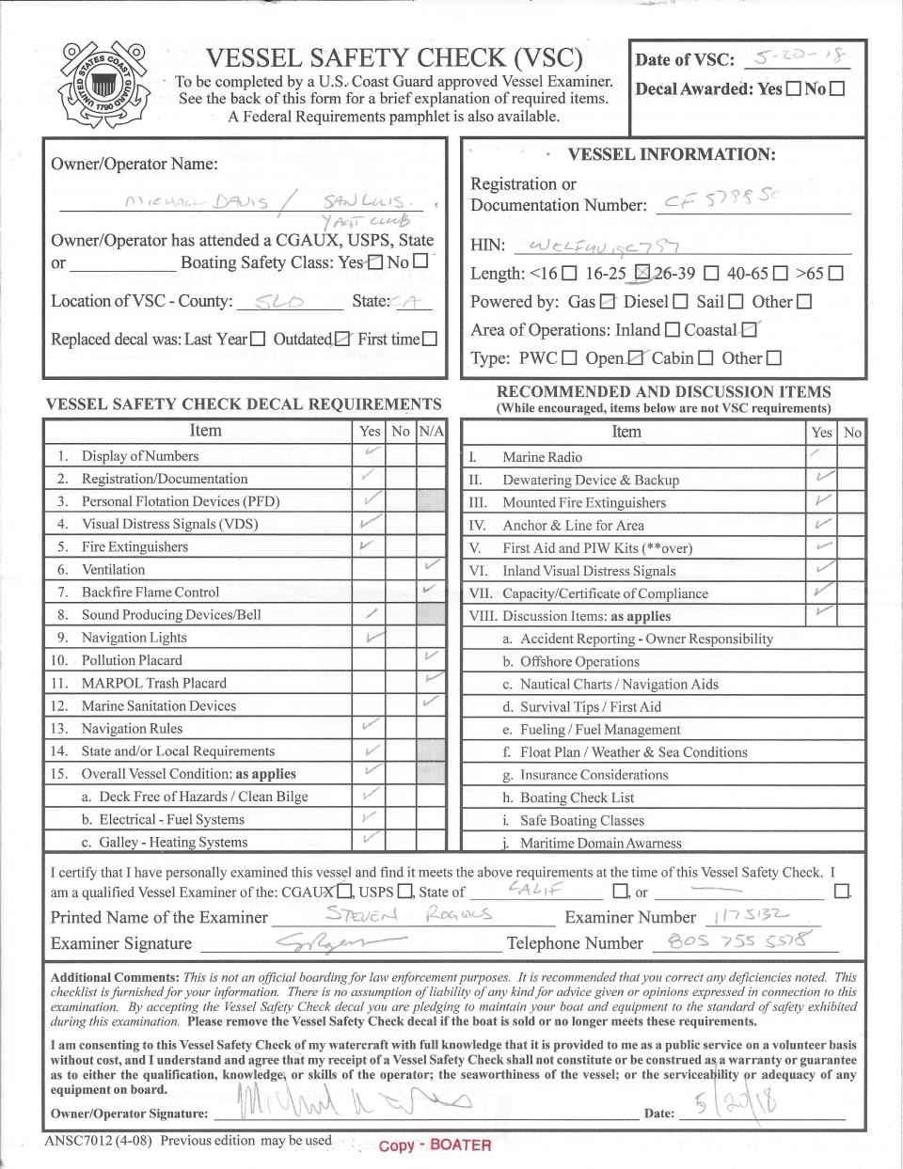

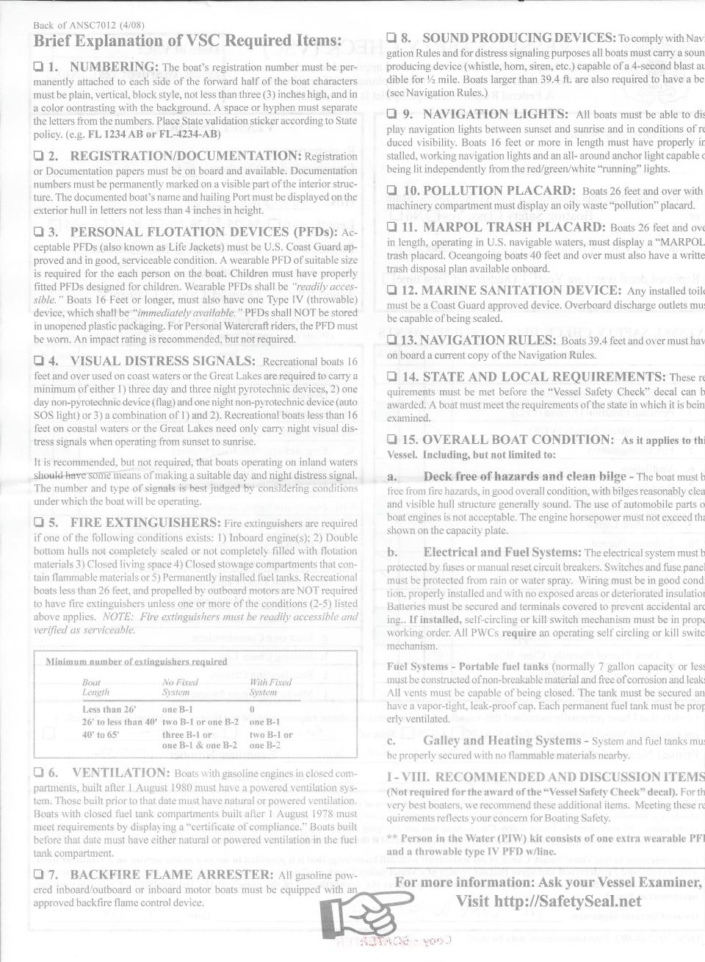
Chase Boat Engine:
2003 115 HP Yamaha Model F115TLRB

Model Information:
F = Four Stroke Engine
115 = 115 HP
T = Power Trim & Tilt / Electric Start
L = 20" Shaft
R = Remote Controls
B = Built in 2003 (1/2003)

SLYC purchased the 2003 engine in 2008, gave it a 15 life and is budgeted for replacement in 2023.

Chase Boat Engine Parts Information:
Fuel Injectors: Fuel Injector Flow Matched, pn 68v-8a360-00-00 for Yamaha Outboard 115 HP Marine
(Aftermarket $40)
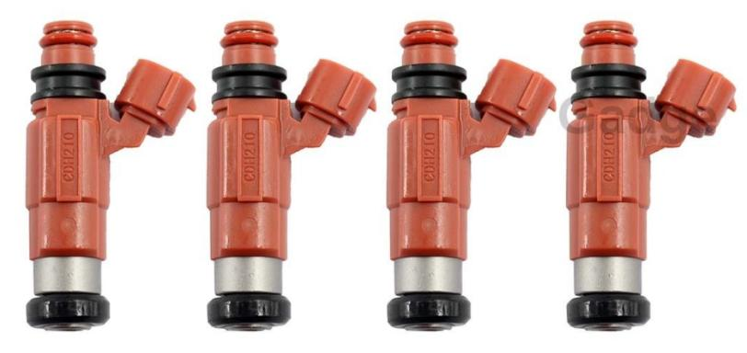

Internal Fuel Filter: Outboard Fuel Filters For Yamaha 68V-24563-00-00 Mercury 881540 75-115 HP
(Aftermarket $12 / 4 filters)
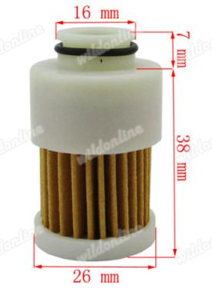

External Racor Fuel Filter
Amazon: Racor 2 Micron Replacement Filter for 445MAM (S3228TUL, S3228SUL, RACS3228SUL), Item 706672015815, ASIN B001HBSYLS

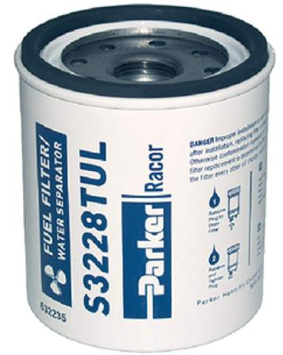

Maintenance Log:

2/2018 Barry Stewart replaced Racor fuel filter assembly including mount, 10 micron filter & bowl. Replaced fuel line between Racor fuel filter and priming bulb. Replaced fuel injectors and internal engine fuel filter.

3/2018 Barry Stewart & Mike Davis changed out the fuel injectors, internal engine fuel filter, and external Racor fuel filter with 2 micron filter. Replaced fuel pressure regulator (aftermarket). Drained fuel tank and added fresh fuel.

4/2018 Installed new Fire Extinguisher

6/2018 Replaced Broken Intel Quick-Fill Rechargeable Air Pump

1/2019 Barry Stewart & Mike Davis changed out the fuel injectors, internal engine fuel filter, and external Racor fuel filter. Flushed the fuel in the engine. Changed the engine oil. Changed the lower gear oil. Drained fuel tank (just over ¼ tank of fuel). Lubricated throttle cables inside engine housing. Added 27.8 gallons of fresh fuel.

