This is a two part procedure:
- Preparing an excel file for Name and Address List (page 1)
- Convert excel member database file to Word Document (page 5)

Prepare the Excel file for “Name and Address” List
4-1-2010
The Excel document should contain only Flag Members, Honorary Members and Associate Members (Exclude “Foghorn” and “Waiting” entries)

Formatting the spreadsheet
- Open Excel
- Insert the names of the fields in the first row of the Excel spreadsheet (“LastName”, FirstName, …)
  - You can cut-n-paste the field names shown below into columns A-N of the first row into the spreadsheet. Don’t worry about how the field names look below – they will paste just fine.
LastName | FirstName | Other | Address | City | State | Zip | Phone | Email | Member | AnivDate | DuesPaid | BoatInfo | Search Terms

- Click in the second row, first cell (A2). This will cause the imported data to begin in the second row (e.g., below the field names in the first row) See figure 1 below

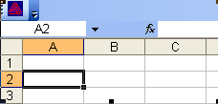
Figure 1

Importing the data (membfile.dat)
- Click on Data, then> Import External Data, then> Import Data. You will see the menu in Figure 2 below.
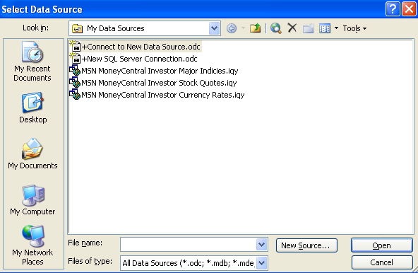
Figure 2
- Select “All Files (*.*) in the Files of type: drop down box at bottom of the menu – as shown below in figure 3. Now you will be able to browse to the membfile.dat file that will be ‘imported.’

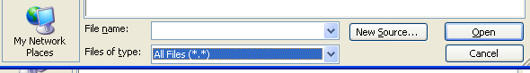
Figure 3
- Work your way to the membfile.dat file, and then select Open. You will see the menu shown in figure 4.
  - Select Delimited
  - Select 1 for the Start import at row: box. (This refers to row 1 of the membfile.dat file)
  - Select Next>
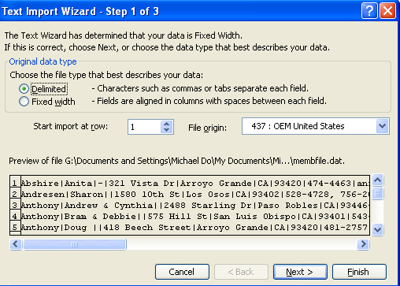
Figure 4

- Next you will see the menu in Figure 5.
  - Under Delimiters, select Other (you may have to deselect Tab.
  - Enter | in the box next to Other:
  - Then select Finish at the bottom right

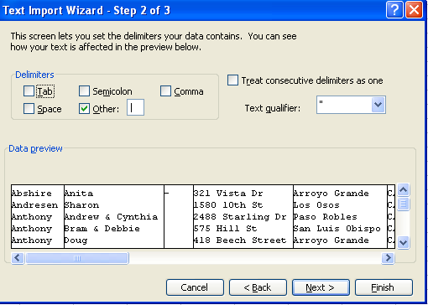
Figure 5

- Next you will see the menu in Figure 6.
  - Select Existing worksheet:
  - Make sure the box says =$A$2 (this means beginning at column A, Row 2) – which is just after the header row
  - Select OK and you will see your completed Spreadsheet
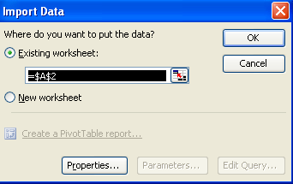
Figure 6

- The spreadsheet will look like Figure 7 (which is a partial view of the spreadsheet)
  - The spreadsheet includes the following ‘Member” categories (column J ‘Member’):
Flag | Honorary | Associate | Foghorn | Waiting |
  - The Foghorn & Waiting categories must be removed.
- Remove Foghorn & Waiting categories
  - The easiest way (I think) is to sort on column J, which will group each of the categories.
    - Delete the rows that contain Foghorn and/or Waiting (they will be together)
    - After deletion, sort on column A (LastName) to return the spreadsheet to the original sort.
  - Save the spreadsheet as Datfile.xls.
  - The next step will be to merge this file into a Word Document, utilizing SLYC Dir Format.doc. See the instructions for making the Word Document
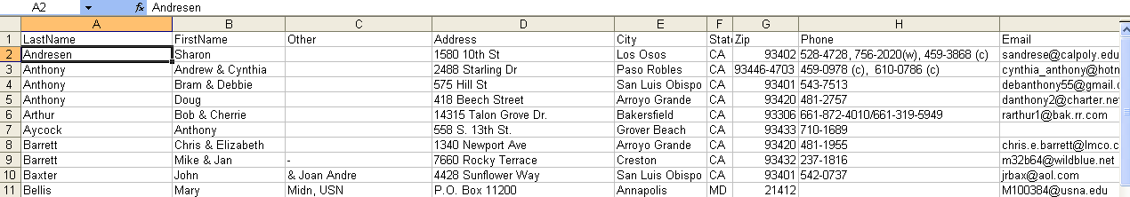
Figure 7
Convert Member Database in Excel form to a Word Document with “Name & Address” List
4-1-2010
- Open “SLYC Dir Format.doc” (this is the main mail merge document)
- The Select Data Source menu (figure 1) will open
- Select (*.xls) in Files of type: dropdown menu
- Browse your way to the datfile.xls file you created from the membfile.dat file, then click Open
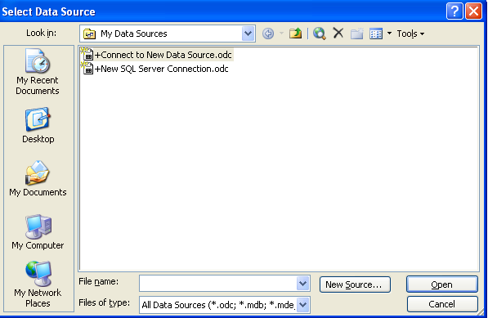
Figure 1

- The Select Table menu will pop up, shown in Figure 2 below.
- Make sure Sheet1$ is selected and First row of data contains column headers is selected
- Click OK
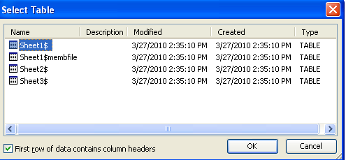
Figure 2

- A preview page will come up, as shown in Figure 3.

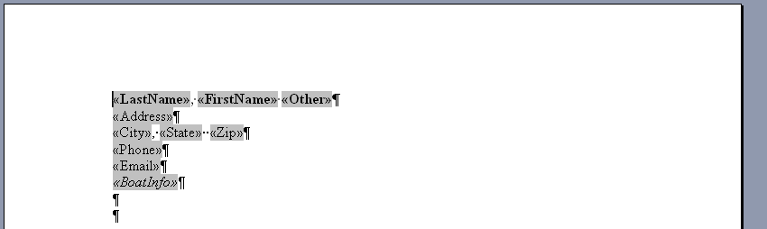
Figure 3

- Select Tools > Letters & Mailing > Mail Merge
- Select  (on right side)
- Select
- Select
- You will see a preview of the directory (first entry) as shown in Figure 4

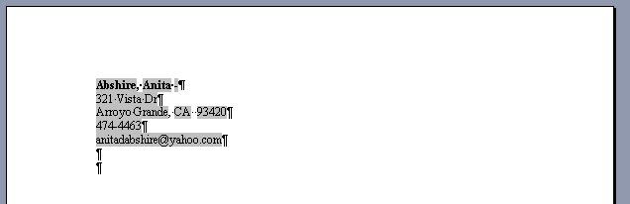
Figure 4

- Select
- Select
- A Merge to New Document menu will appear as shown in Figure 5
- Select All, then click OK

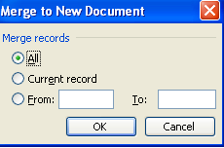
Figure 5

- You will see the directory of members, in one long column (30+ pages), as shown in Figure 6
- Save this list (suitable name) for future use

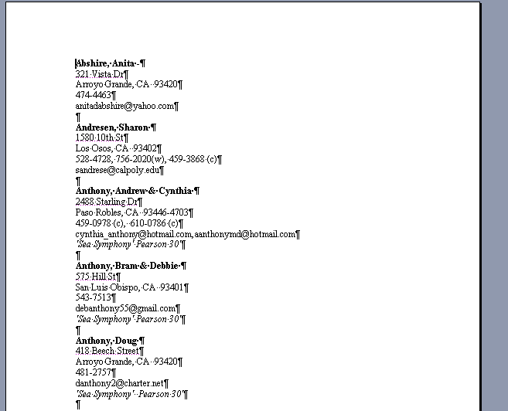
Figure 6

