July 4 Parade of Boats
Procedures
10-1-2008
March:
*Apply for Special Event Permit with the Port in March. (Sample in office)
*Provide Port with a certificate of our Liability Insurance. (Sample in office)
*Find inexpensive entertainment for on the pier by the yacht club. (Sample in Office)

April: Publicity
*Posters and flyers to be done for the parade. In the past SLYC member Ruth Donnelly has done them for us. (sample in office)
*Contact SLYC member John Sorganfrei to help with advertising.
*Contact Guy Hackman SLYC member to ask for radio time advertising on his radio station K-Jewel.

May:
*Contact Port to request the Port San Luis Fire Boat to lead parade!
(Marine Safety)Greg Weisberg 595-5435,gregw@portsanluis.com

June:
*Hand out posters the middle of June to local businesses and leave flyers for them to pass out to customers.
* Provide maps of route for parade at June Wet Wednesday.
* Announce parade in Foghorn and by e-mail advertise for participation.
*Go to Port Monthly Meeting to announce the parade and invite the Commissioners to be in the parade.
*Contact participants from previous year to get commitments to be in parade and send e-mails.
*Provide maps of route at June Wet Wednesday. (sample in office)
*Confirm Avila Trolly, Coleen 440-2775 or Boyd 595-2213 will be making runs from the port to the Avila Pirate Park to bring our sailor to and from for Jimmy Buffet Days celebration!(traffic is an issue and sailors won’t have to move their cars after launching their boats until they go home for the day!

End Of June
- Confirm, confirm all of above and your participants:>)

JULY 4 Have fun!!!!!
Typical Parade Route
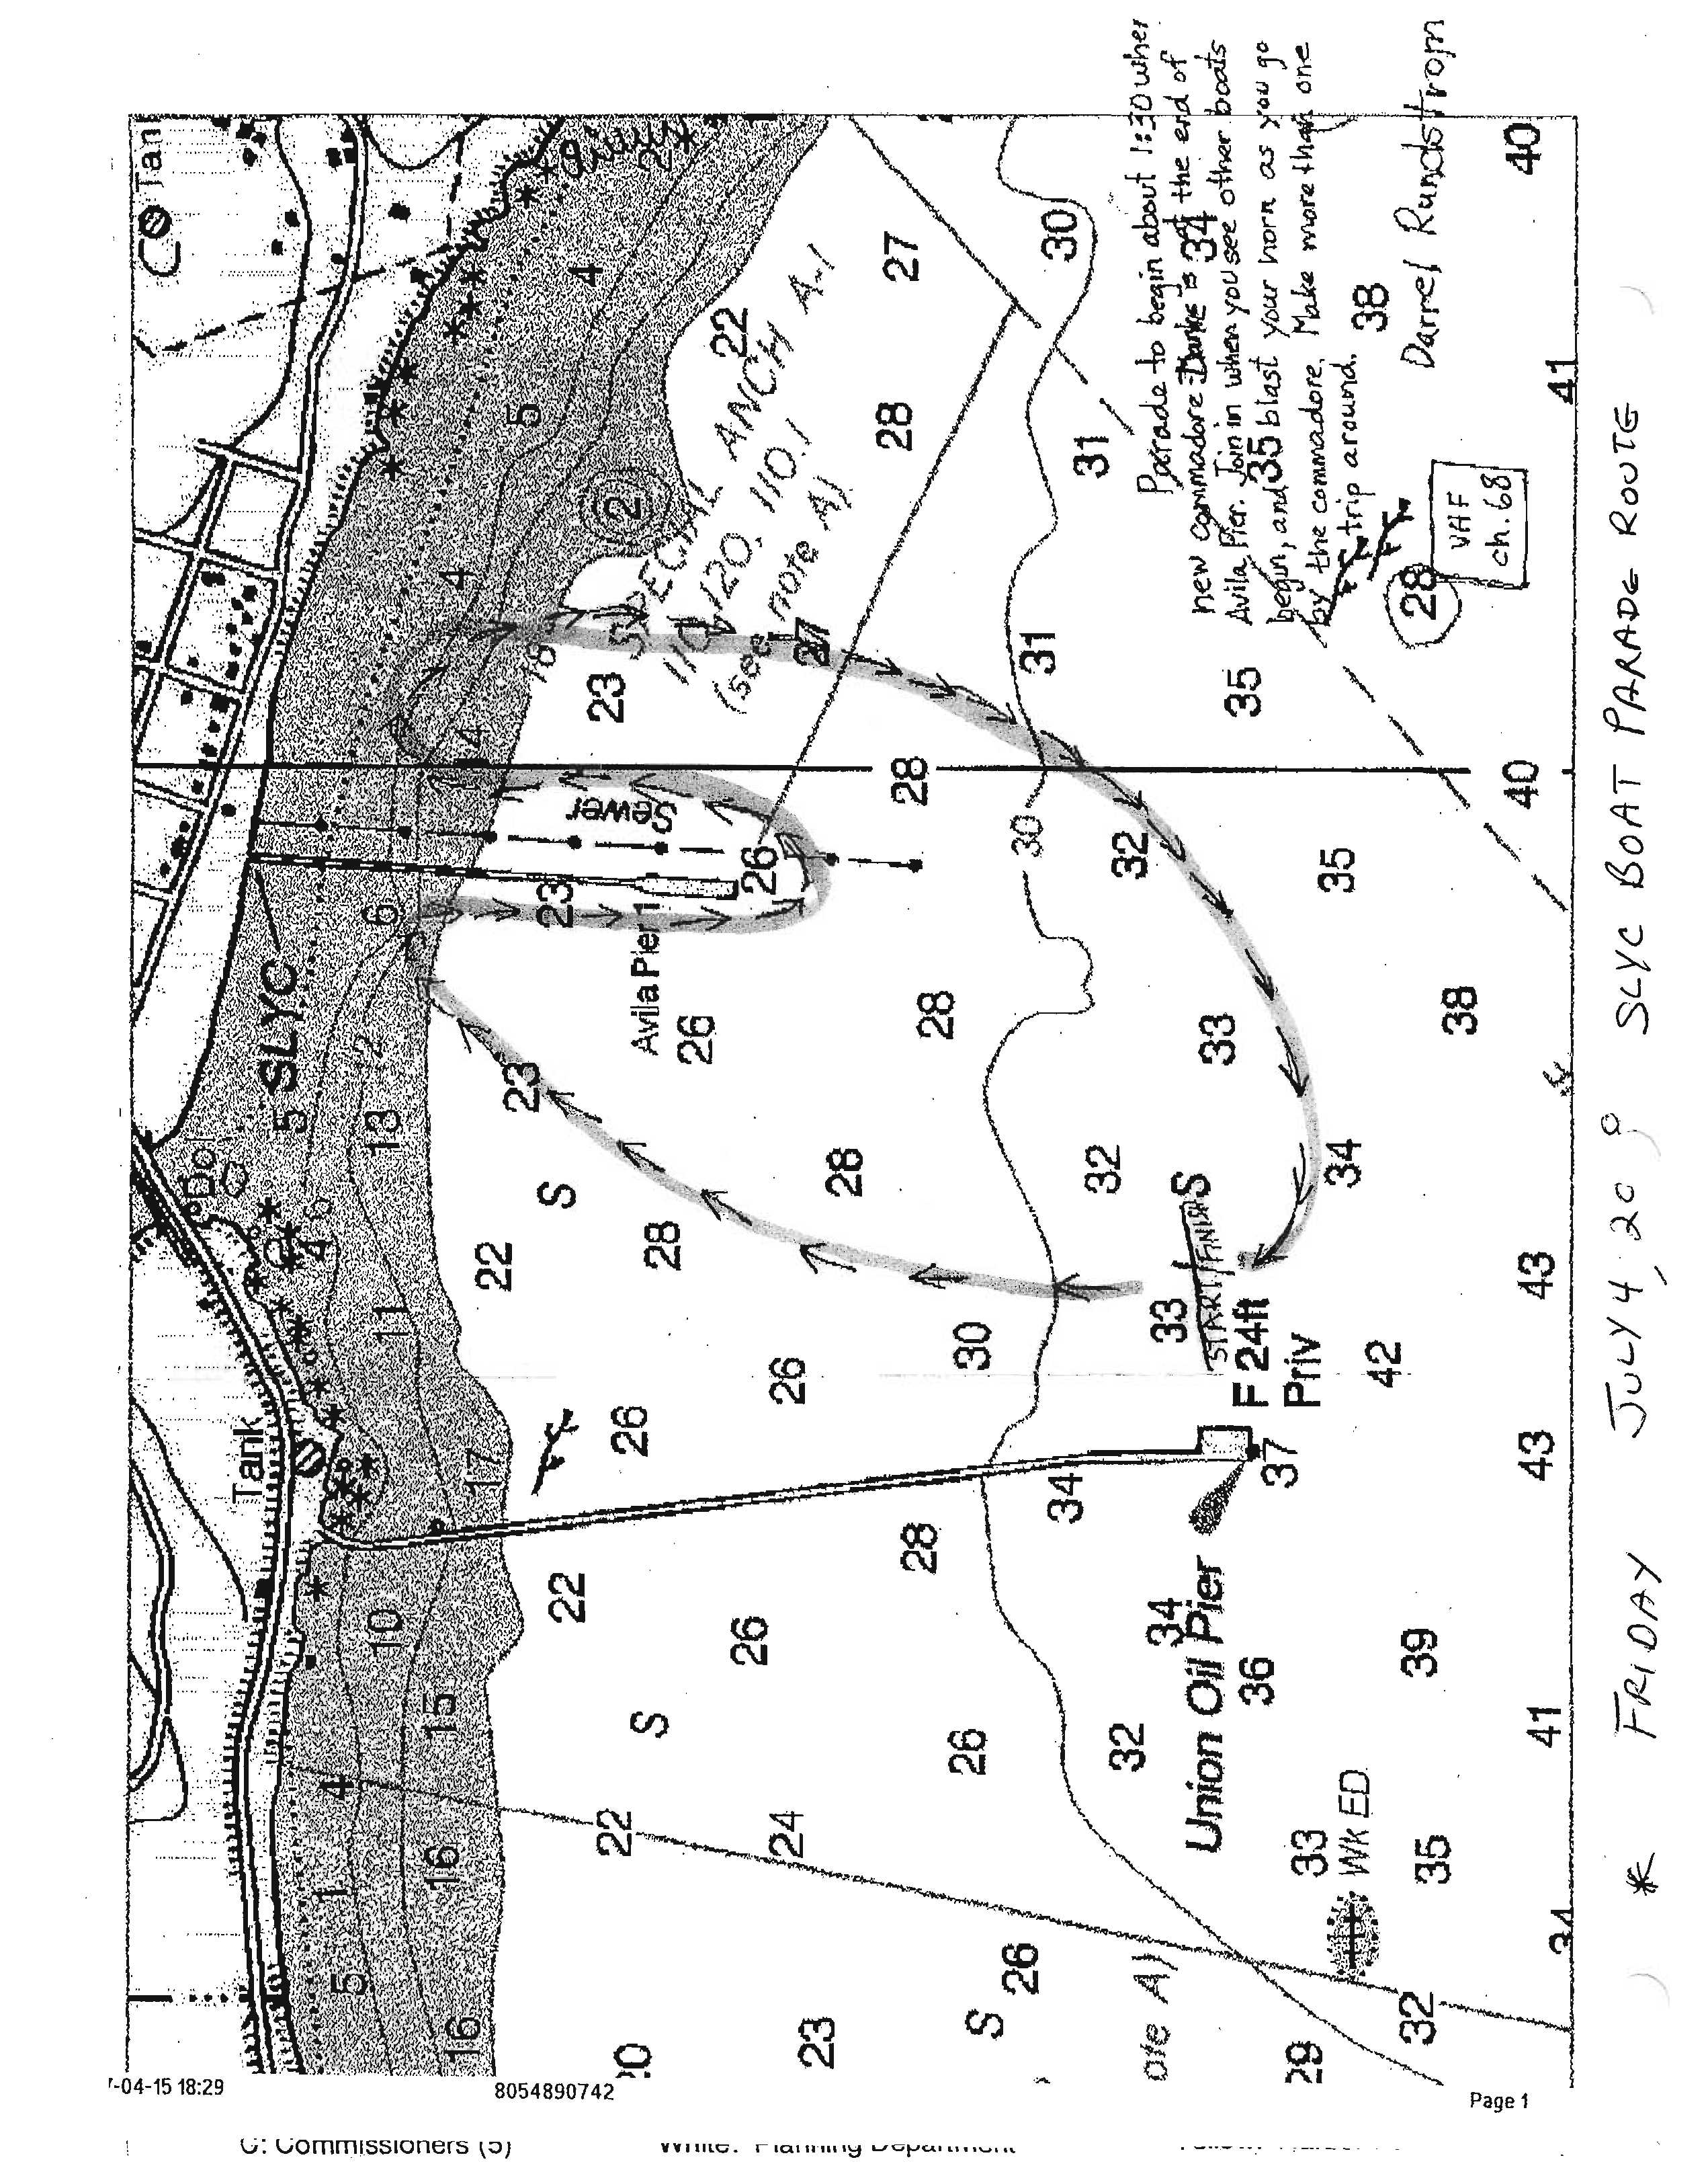
Typical Special Event Permit
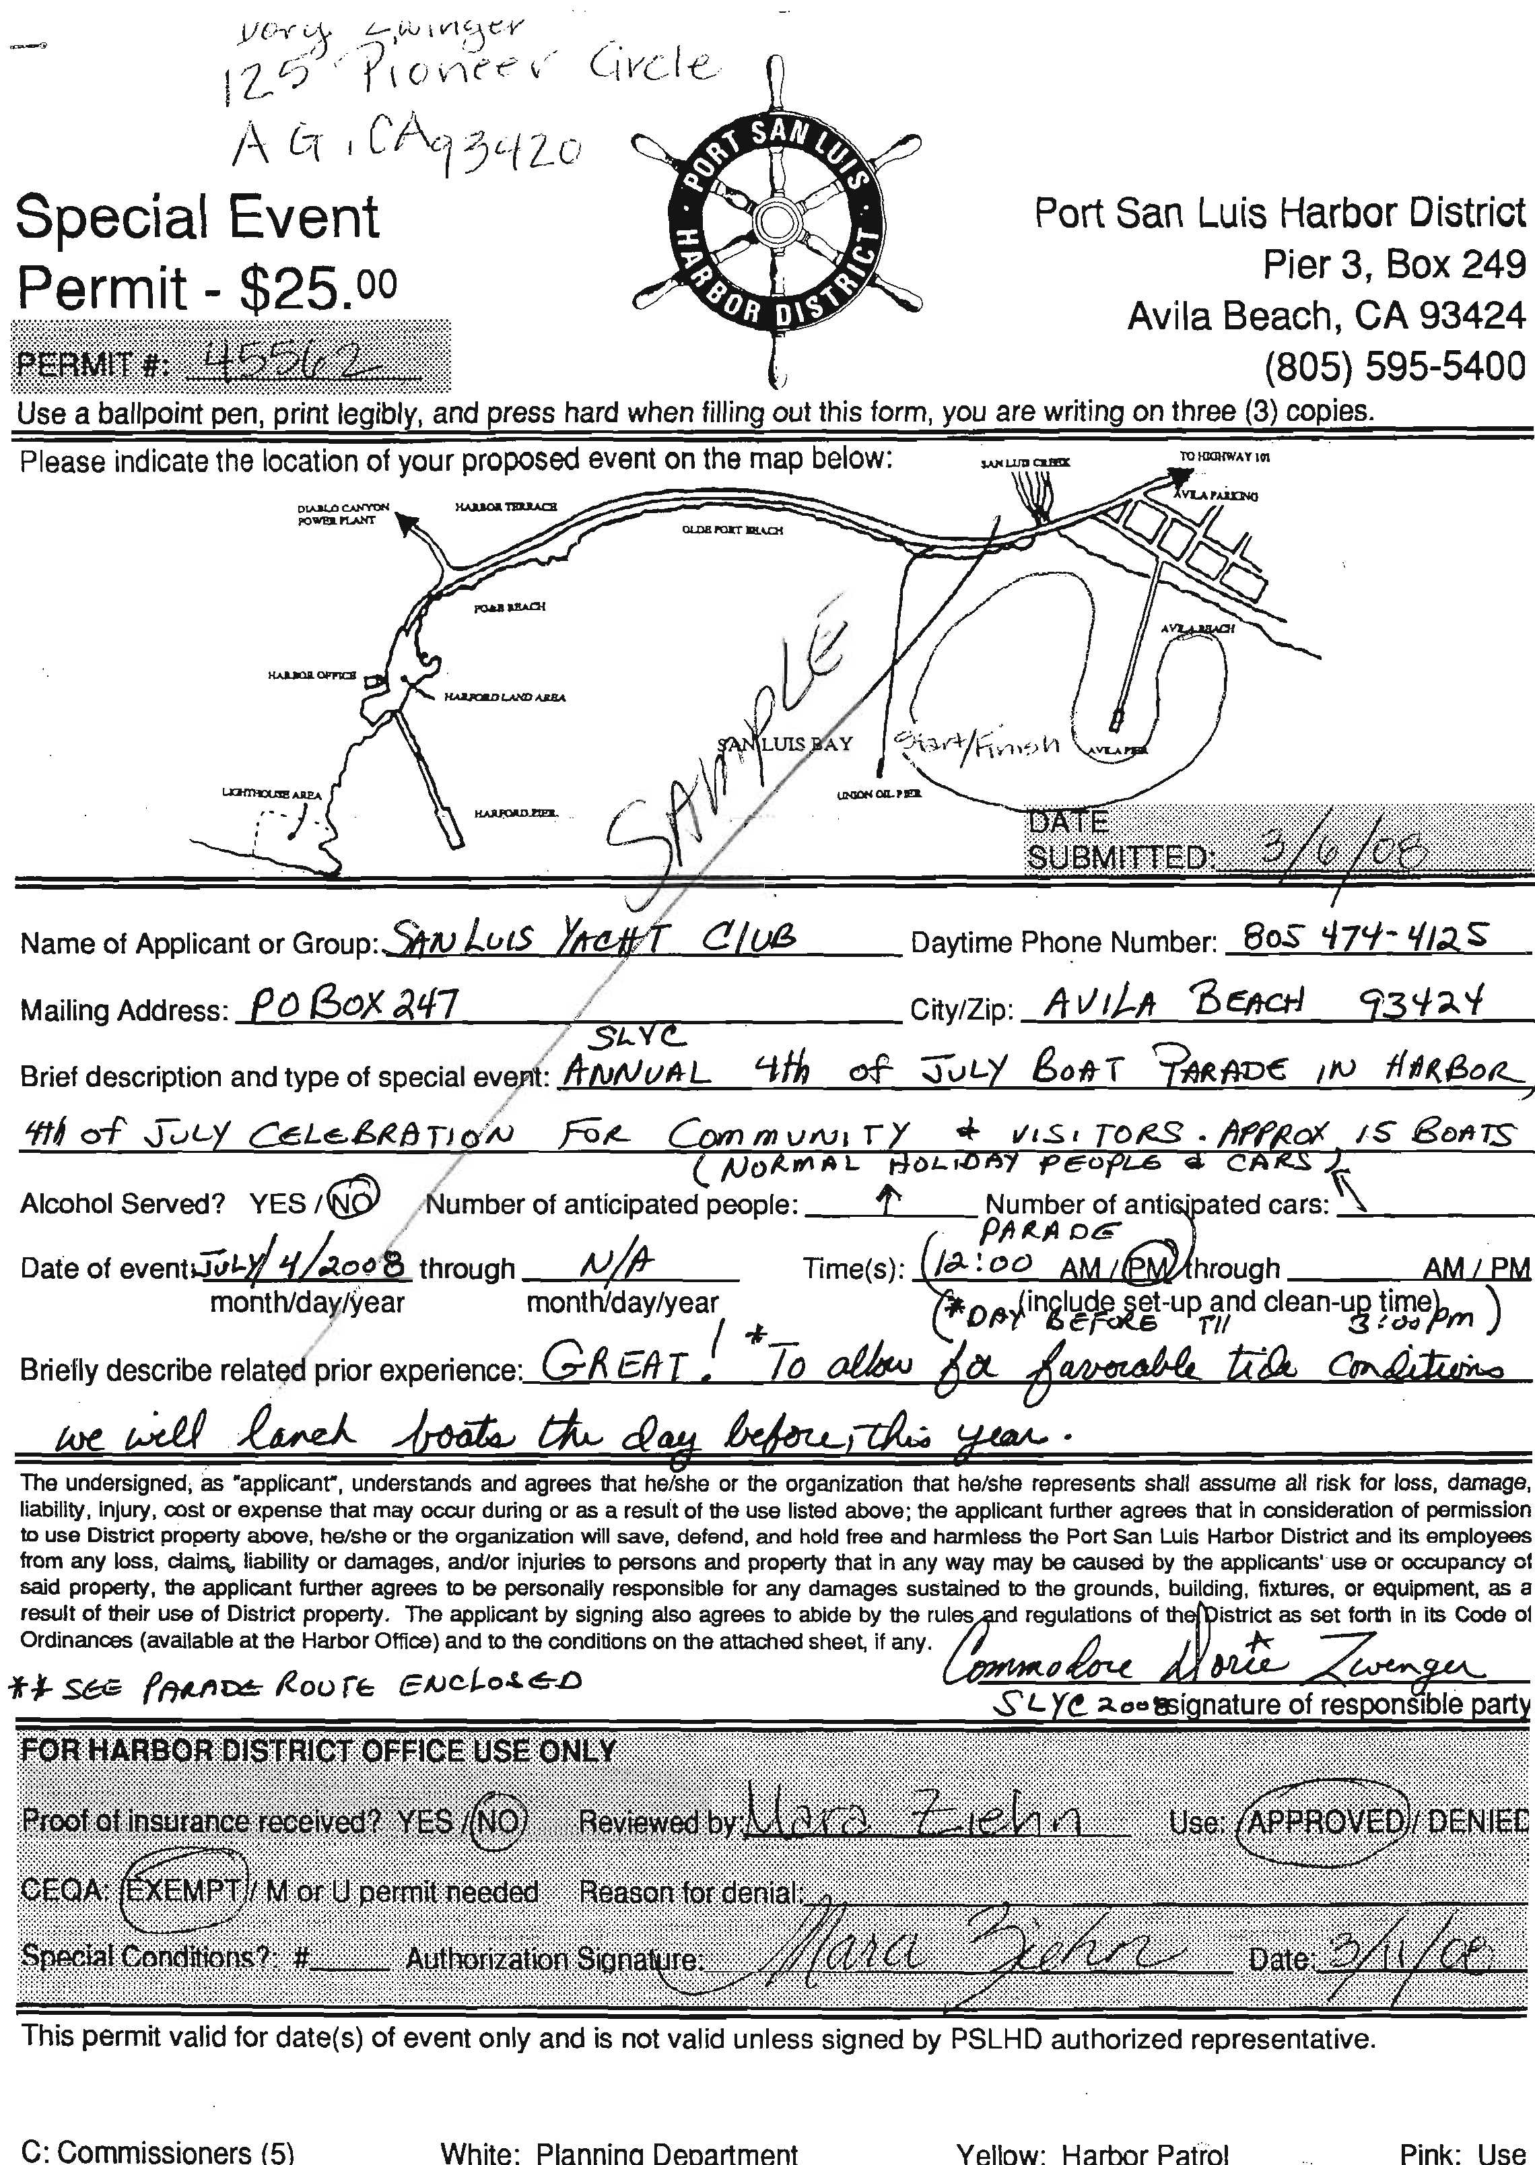
Typical Certificate of Liability Insurance
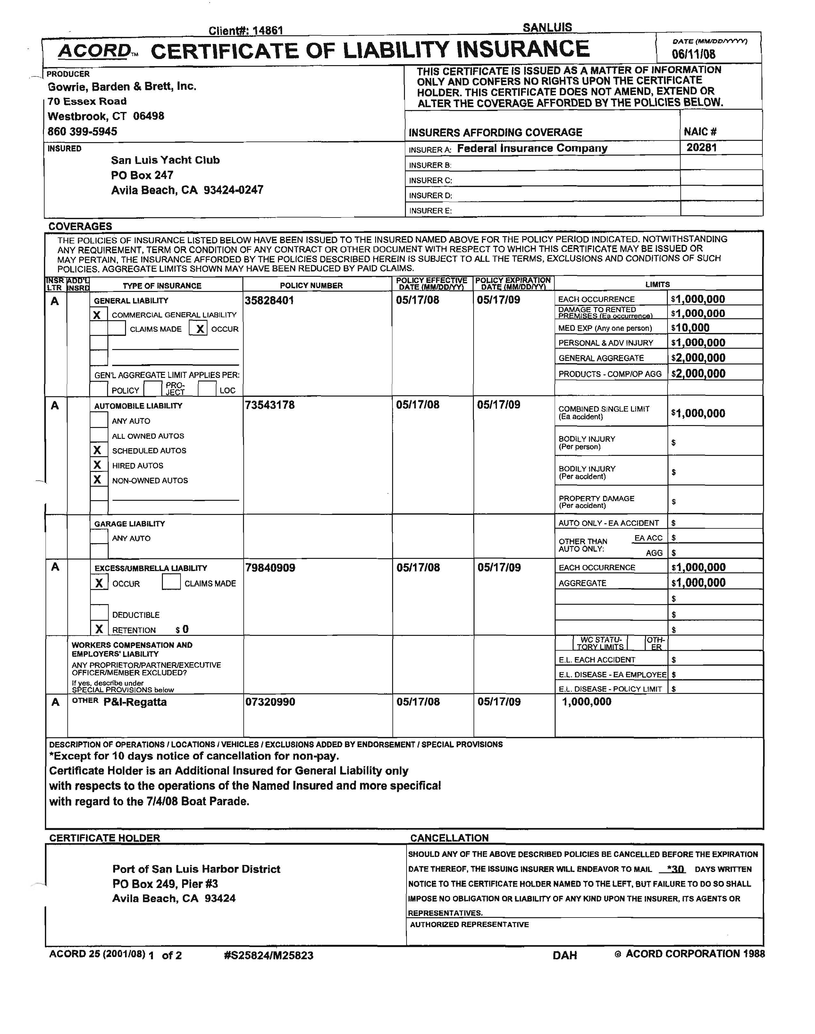
Avila Trolly Brochure
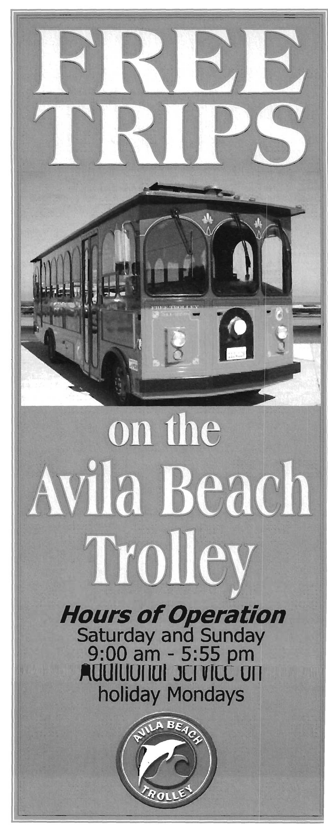
Typical Trolley Schedule
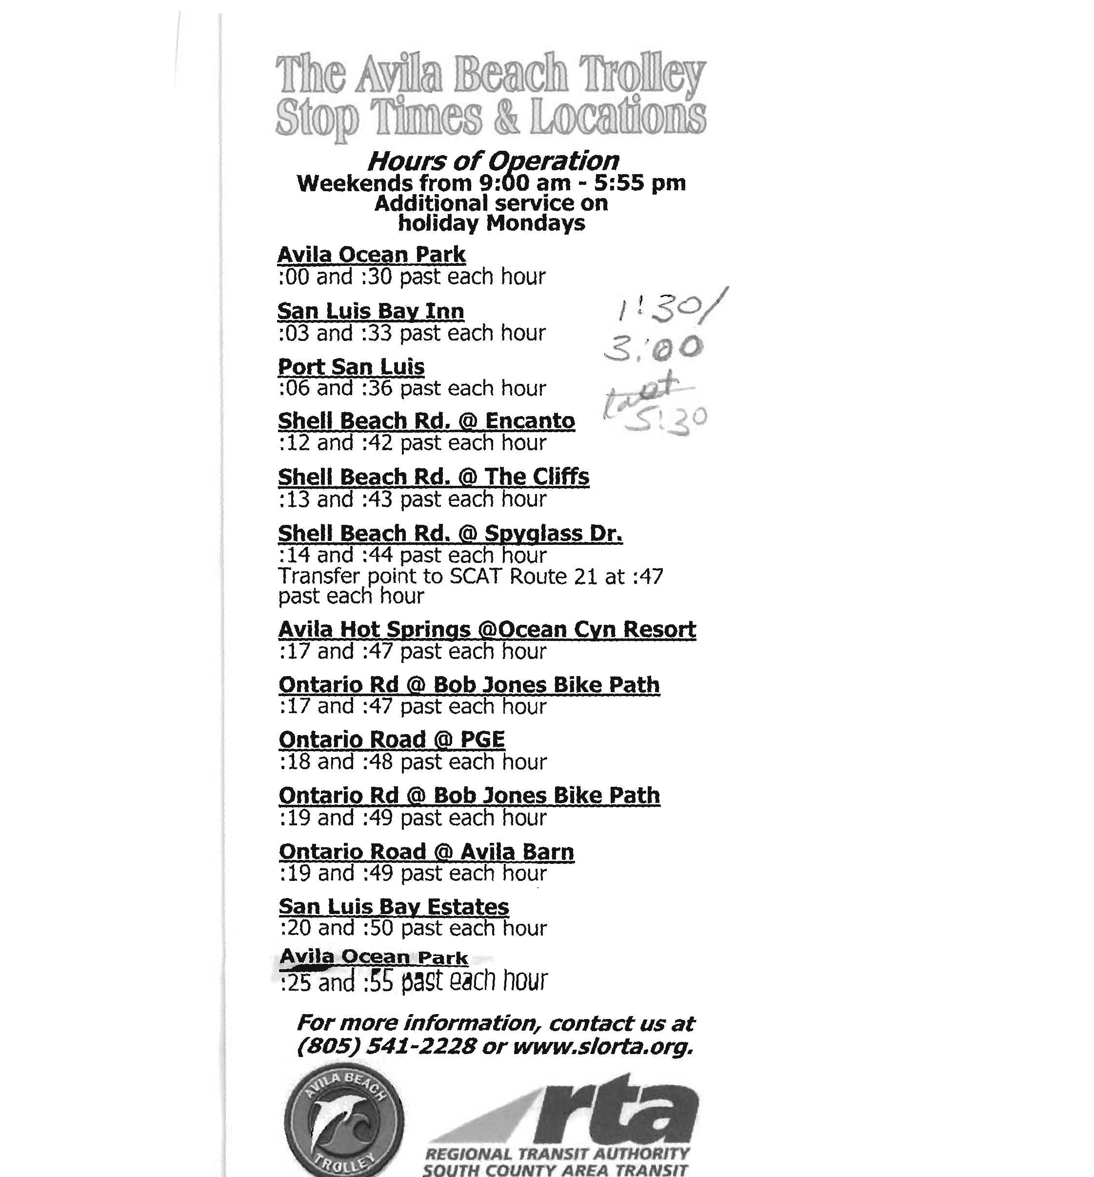
Typical Flyer
