Making Sign-in sheet for the General Meeting
(Flag & Honorary Members only)
11-13-15
- Open Database and select 'Search'
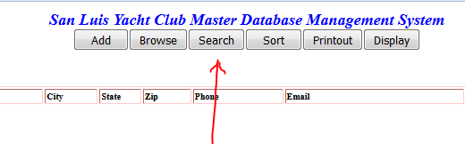
- Enter flag honorary in the "SEARCH by Keywords:" box, and select 'Member" field for the search
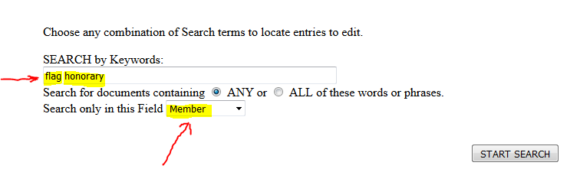
- This will result in a listing of all "Flag" and "Honorary" members, sorted by LastName.. If you go to the bottom of the Database page, you will see that there are around 215 entries (200 flag plus 15 or so Honorary entries).
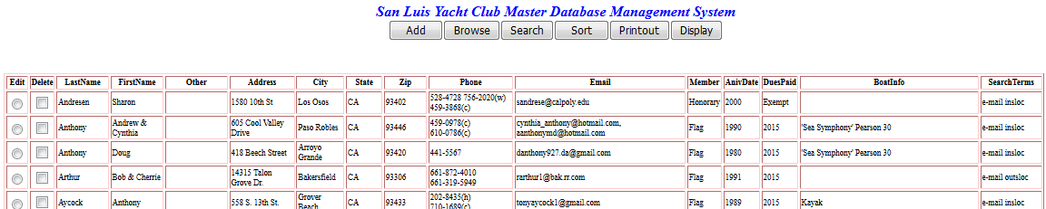
- Now you select the columns LastName thru Member fields to paste into a word doc. Do this by pressing Ctrl while using the mouse to select the LastName thru Member columns, from top to bottom and across. The selection will look similar to below (partial image).
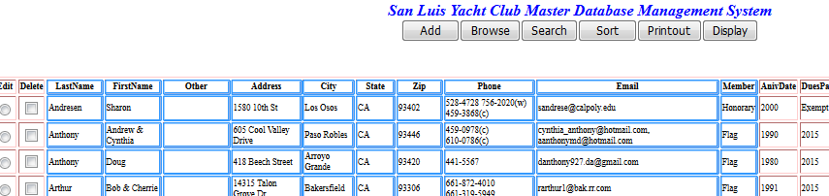
- After pasting into the word doc, it will look similar to below, where the table is too big for the width of the page. This is fixed by selecting 'Auto Fit', then selecting 'AutoFit - Contents'
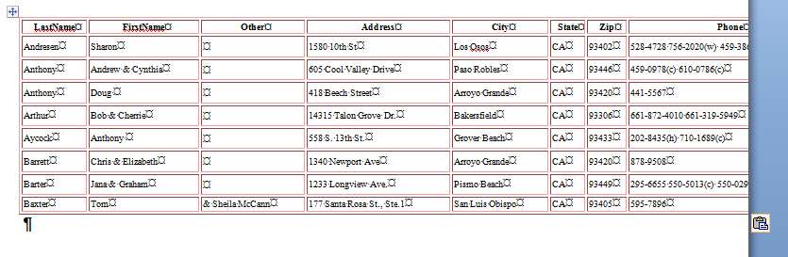
- After selecting autofit contents, it will look like below. The next step is to delete the Address City State Zip Phone & Email columns, leaving LastNamd FirstName Other & Member columns. (The Other column includes second last names as applicable)
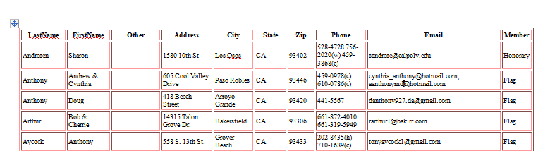
- After removing the above columns, you are left with the desired fields. From here you can format the columns as desired for the "sign-in" sheet
