What You Should Know to be Officer of the Day (OD)
April 2017

GENERAL
Please contact your hosts within one week of your assignment to confirm their attendance and coordinate any purchases for the event (for example, appetizers for a social). Please arrive well in advance of your hosts. During this time, deploy the U.S. flag and the SLYC burgee, put the liquor out, unlock the beer and wine coolers, and retrieve the bar checklist located on a clipboard in the bar closet. If you are going to use Square, get the iPad and check it to make sure that it and the square card reader is charged. Instructions for using Square are attached to the end of this document. Fill each of the three bar sinks with hot water. Soap goes in the left sink, bleach (2 capfuls) goes in the center sink, and the right sink is just hot water rinse. Please write your name as the ‘OD’ and the bar hosts on the white board.

It your responsibility to ensure that club rules are followed. These include:
- Ensuring that no one under 21 is served.
- Minors are not allowed to sit at the bar when it is open.
- All members and their guests who are served alcohol are wearing nametags. If someone is wearing a guest nametag, ask them who they are with.
- No outside alcohol is consumed while the bar is open.
- Hosts and Officers pay for all the alcohol that they consume.
Please make sure that hosts are also aware of these rules.

KEYS
The keys which open the safe, trophy cabinets, quartermaster case, etc., are located in a key box inside the office, with appropriate descriptions. PLEASE BE SURE THAT THE O.D. RETURNS THE KEYS TO THE PROPER HOOK AT THE END OF THE NIGHT.

The key to the bar area (beer & wine coolers and kitchen refrigerator) is on a separate key ring on a nail just inside and to the left of the Liquor closet door (pictured below).
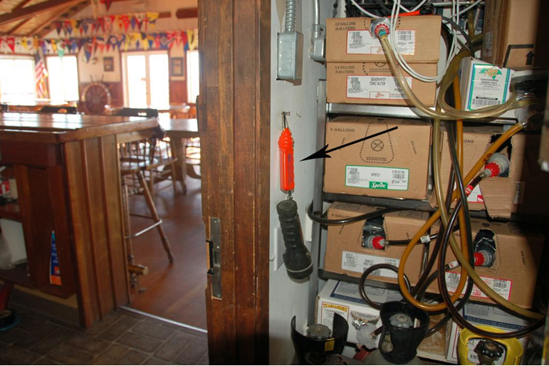
HOSTS
Please remember that hosts are not your subordinates. They are fellow members who volunteer their time to make the Club work for all of us. It is your responsibility as OD to ensure that the bar hosts are trained about the bar. The Bar Checklist (attached to the back of this document and located inside the bar closet) provides useful information to go over with the hosts. Please encourage hosts to only open wine as guests order it. Please make sure that hosts do not open more than one bottle of the same liquor or wine at the same time. This leads to waste as wine and liquor start to go bad after being opened.

When your hosts arrive, ask one of them to assist you in counting the money for the till. Open the safe and get the till money from the red envelope. Count out the opening till amount with your host as witness. You should have $100 to open the till. Also, make sure that the duck is out for tips. Please note that the bar must have its own envelope but it can include Ship’s Store purchases and tip money from the duck. All other charges including meal charges should be placed in a separate envelope.

DURING THE NIGHT
- Extra wine and cocktail glasses are located in dishwasher crates on the top shelf in the bar closet.
- If you need to make change, use the gray bag located in the safe. Please make sure to take money out of the till to make change so that the total cash in the gray bag remains as it was when you first opened it ($300).

END OF THE NIGHT
- Ring the bell and announce last call.
- Train the hosts about restocking
  - Load the beer refrigerator with warm beer in the back (do not break six packs)
  - Load the wine refrigerator with 5 bottles per shelf in this order (from top to bottom):
    - Chardonnay
    - Sauvignon Blanc
    - Pinot Grigio
    - Rosatto and Champagne
  - If a case needs to be opened, please the entire contents of the case out on the proper shelf in the bar closet
  - All spirits and mixes should be placed back on the shelves from which they came
- Ask a host to assist you in completing the envelope
  - Count out $100 from the till (using low denominations, if possible) and place it in the red envelope
  - Make sure that the gray bag has $300 in it at the end of the night
  - Check off your volunteers using the form inside the red bag
  - Count the tip money (in the duck) separately and list it on the envelope; then place the tip money in the till
  - From till, reimburse hosts/cooks for their expenses, place the receipts for their expenses in the envelope, and complete the ‘Expenses paid in cash’ portion of the envelope
  - Count the remainder of the till money, fill out the envelope, and place the cash and checks in the envelope
  - From envelope, reimburse hosts/cooks for their expenses, place the receipts for their expenses in the envelope, and complete the ‘Expenses paid in cash’ portion of the envelope
  - Sign the envelope (both you and your host) and place it in the deposit safe in the bar closet (the black box to the right of the safe).
- Ask a host to remove the trash and recycling and place it in the appropriate bins outside.
- Complete the ‘Closing the Bar’ checklist
TROUBLESHOOTING

DRINK DISPENSER SYSTEM
Bar tenders need to know what comes out of the drink dispenser when you push the buttons on the nozzle. A placard, similar to that pictured below, is located on the bar near the dispenser.

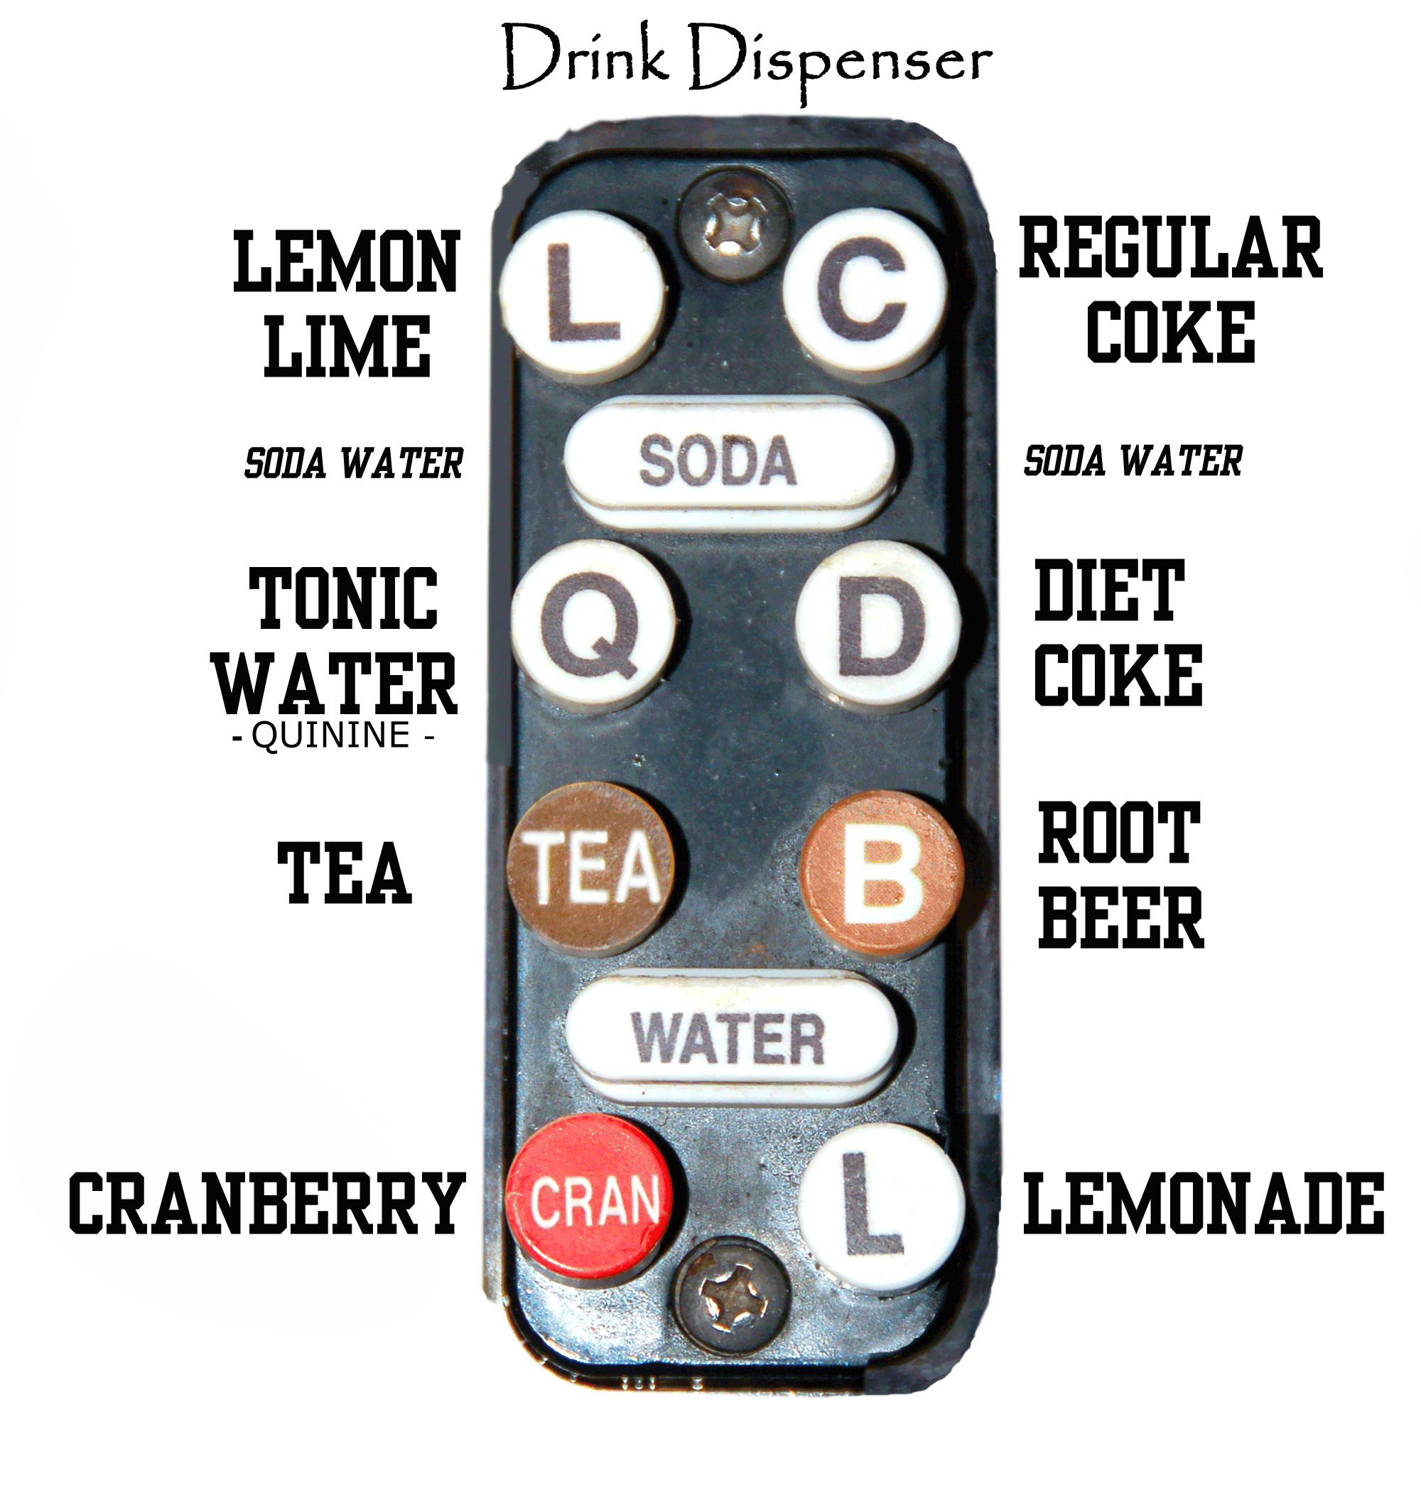

You may have to troubleshoot the drink dispenser. These are some common problems and solutions:

- DRINKS COME OUT WEAK
The syrup may be empty, change the bag if necessary. To replace the bag, unscrew the orange knurled piece, as shown below, locate a replacement bag (if available) and screw the piece back in.
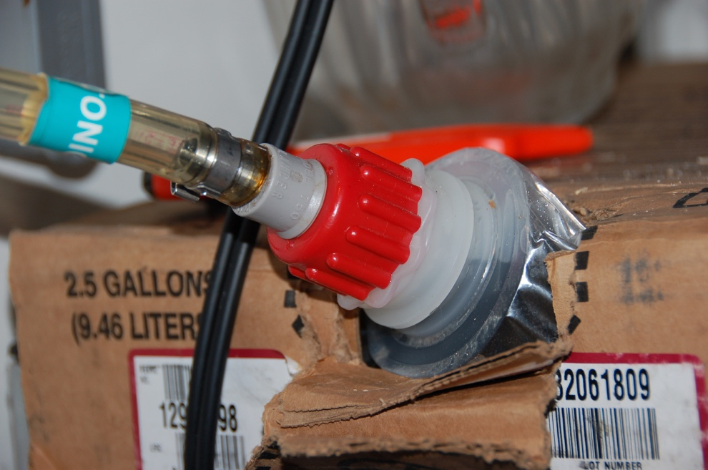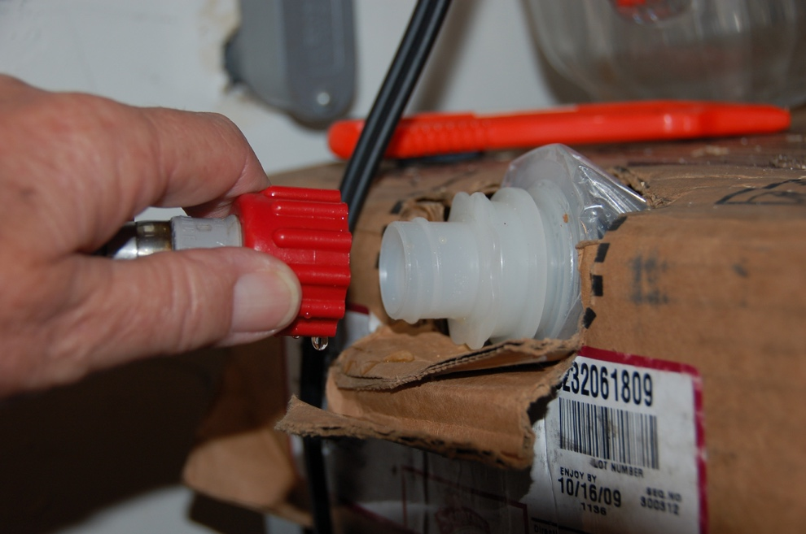

- DRINKS ARE FLAT
The CO₂ may be empty.
    - Check the gauges – this should indicate if a tank is empty.
    - You can also check this by having someone dispense some soda while you are in the liquor cabinet. You should hear repeated pss-taaa as the soda is dispensed. If there is no sound, then the CO₂ bottle is probably empty.

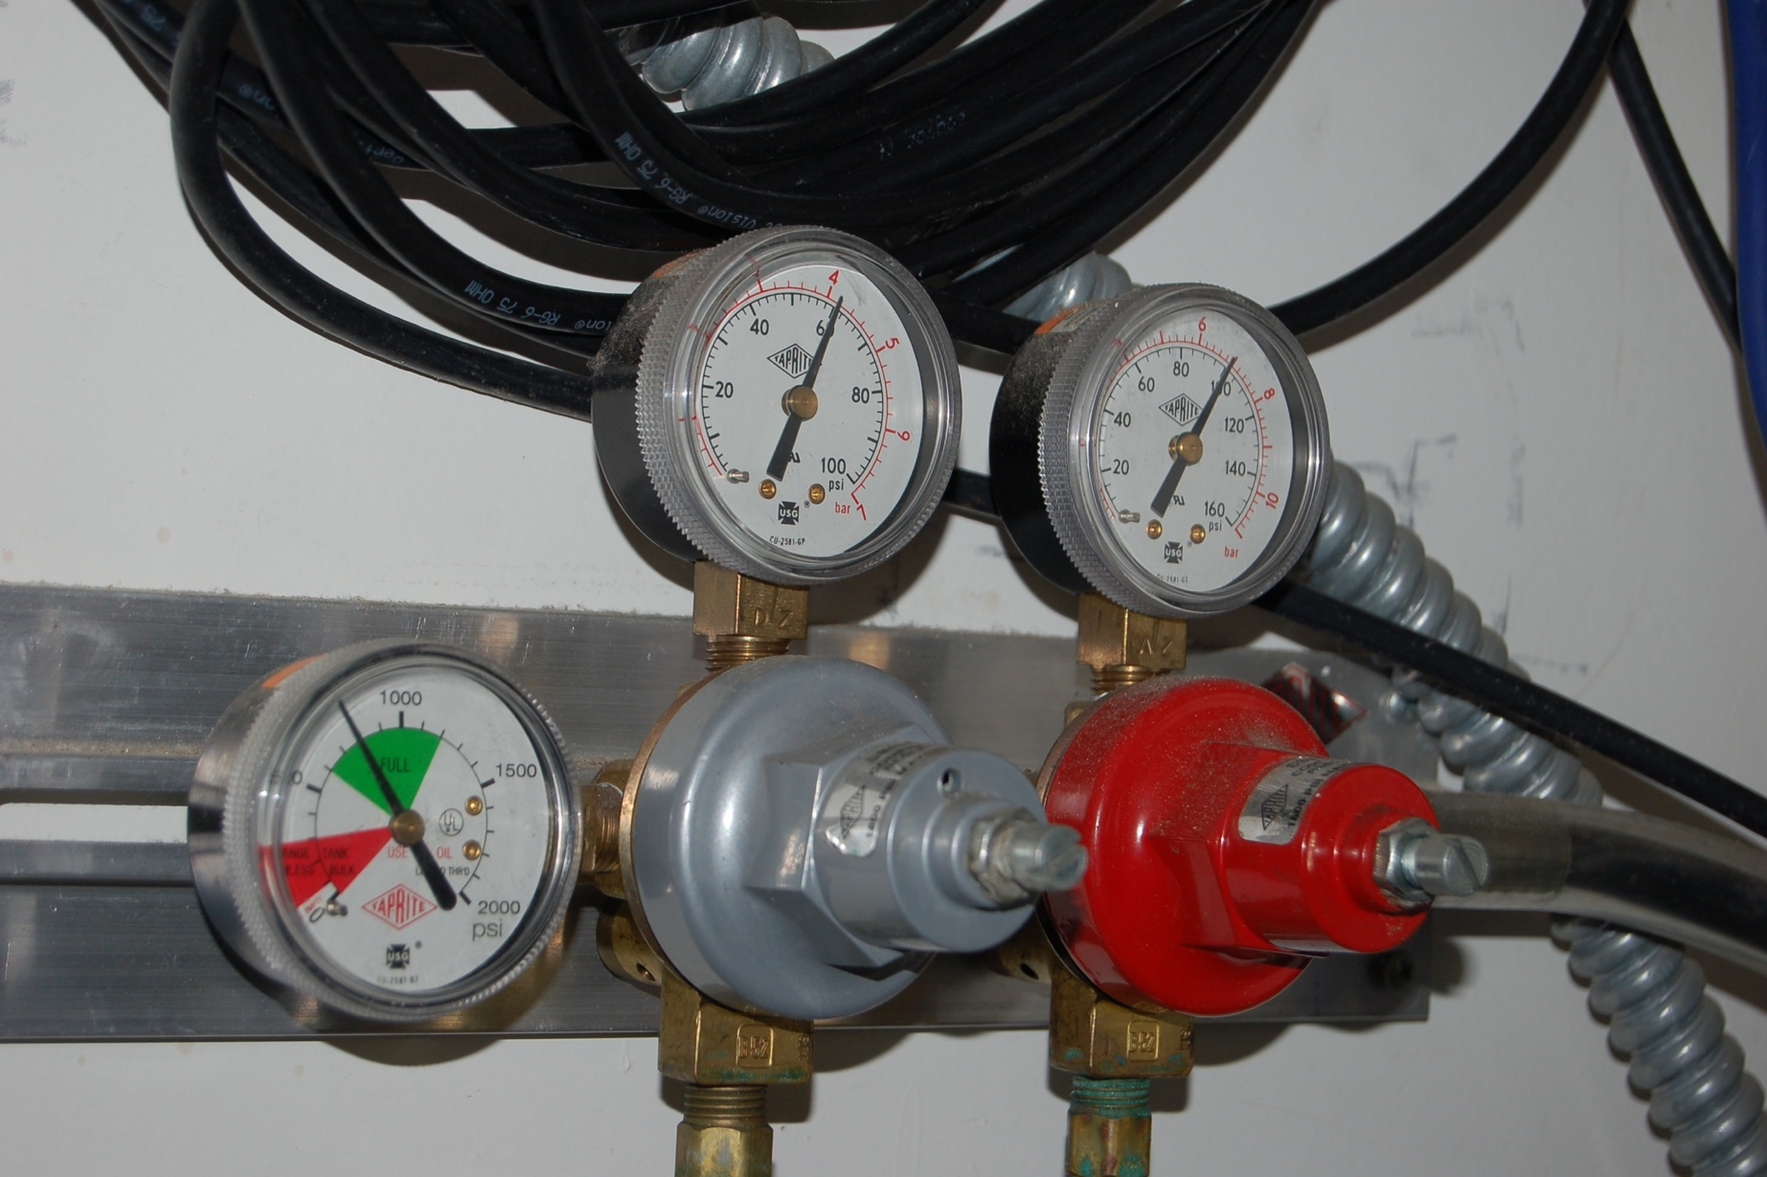

An empty bottle is lighter in weight than a full bottle.
    - There is a wrench attached to the hose for changing bottles.
    - Make sure to insert the washer included with the new tank.
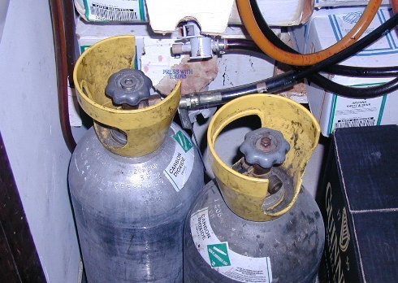

- NO SODA WATER
  - Make sure that there is ice in the jockey box on the left side of the bar. A layer of ice is required for the carbonator to function.
  - Check the soda-generating compressor under the Jockey box and plug it back in if necessary. See the picture on the next page.
  - Check that theice machine is plugged in plug in the ice machine if necessary. Some groups unplug it because of the noise and forget we need ice on Friday night and brunch Sundays.

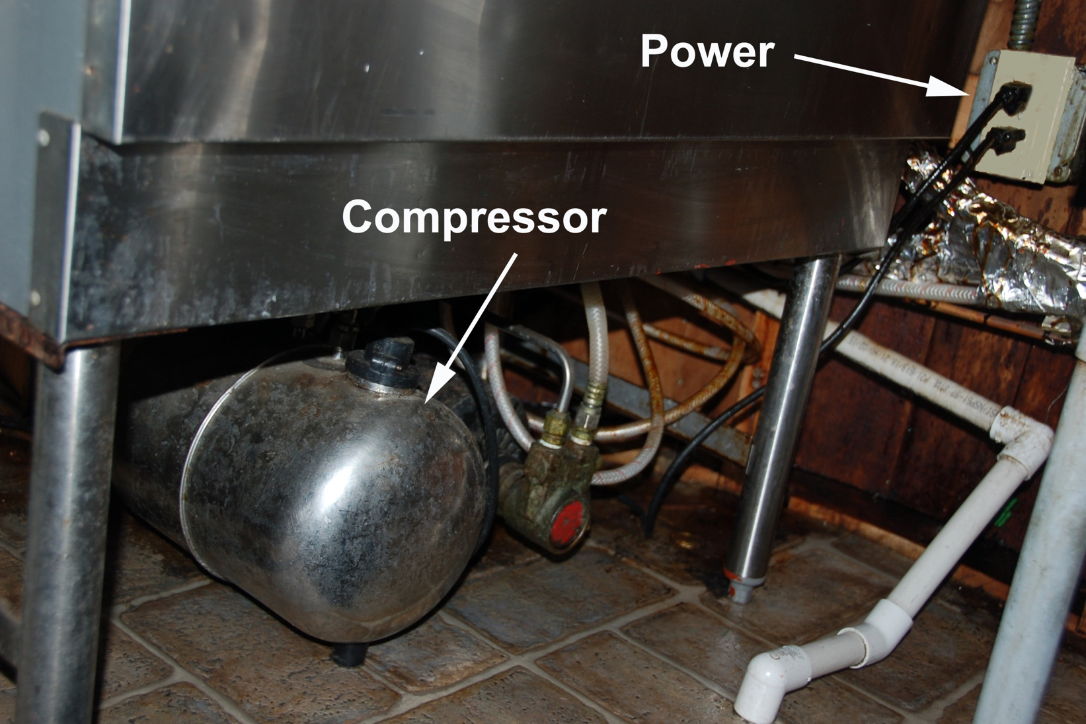

- GUN IS NOT DISPENSING PROPERLY
Make sure the nozzle on the gun is clean, you can take it off and rinse it.
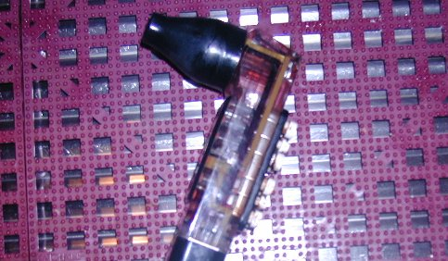
- HISSING SOUND COMING FROM THE DISPENSER SYSTEM IN THE CLOSET
If the sound is coming from the tank:
  - Turn the CO₂ OFF
  - Unscrew the hose
  - Replace the washer (or put a washer in if it isn’t there)
  - Turn the CO₂ ON

If the sound is coming from the solenoid bank:
- Determine which solenoid is producing the sound
- Turn the CO₂ OFF
- Slide the pin connecting the supply CO₂ so the supply line can be disconnected (see picture)
- Pull the supply line away from the solenoid and make sure there is nothing pressing against the end
- Turn the CO₂ ON

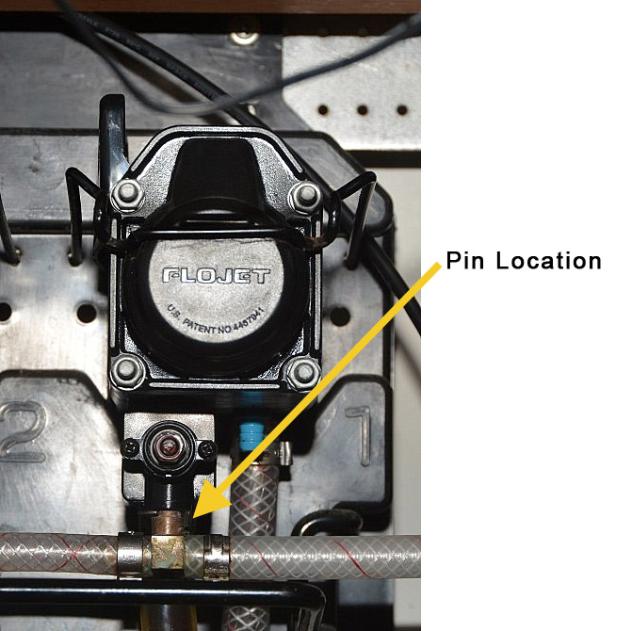
ADDITIONAL INFORMATION

BACK DOOR
The back door does not always lock when swung shut. Make sure that it really is locked before leaving. It is quite often found unlocked the morning after some social gatherings.

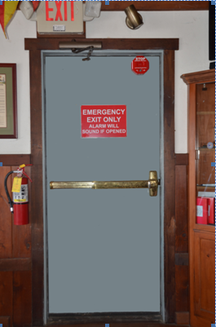

TRASH ENCLOSURE
All trash must be inside the two containers and this includes any cardboard boxes. This directive comes straight from our Landlord. If the containers are full, take it home or leave it in the cans on the deck so as not to smell up the club house. Combination is 7676. If you need a flashlight to see, one is hanging with the keys on a peg in the liquor closet.

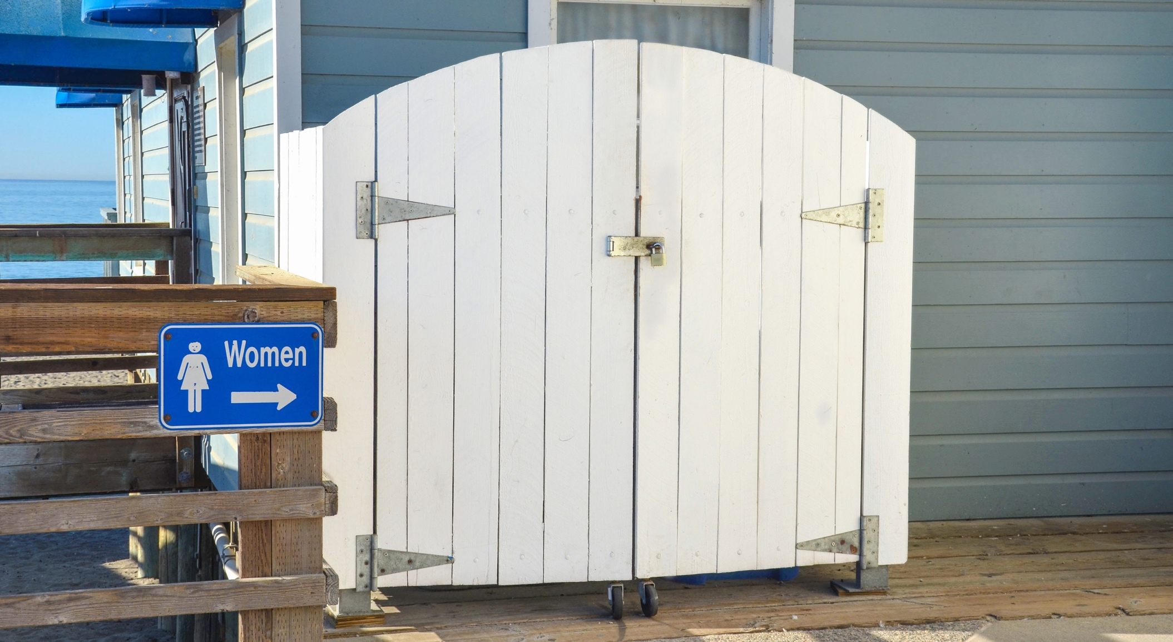
DRIVING TO THE FRONT DOOR
Enter and exit from San Francisco street (west of the club), as denoted by the arrow in the picture below. There is adequate space –the bollard(s) do not need to be moved.

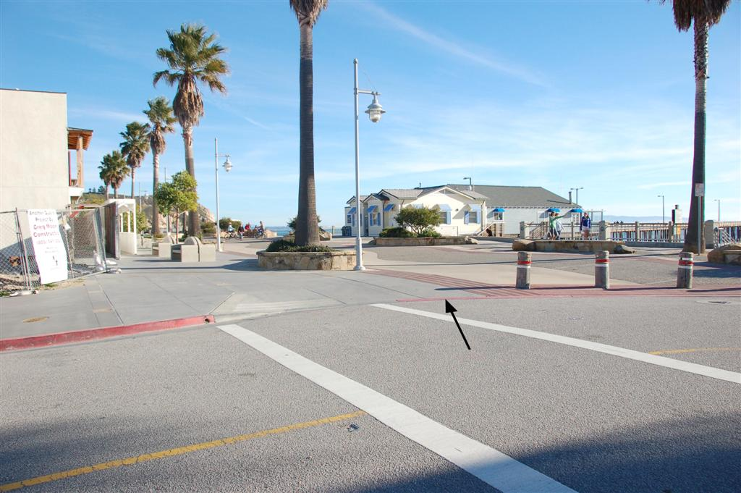

ADDITIONAL DOCUMENTS
Short-Form Instructions for the Square Register
(Used for ringing up credit card sales)
Revised March 2017

- Turn on the iPad.
- Enter the 4-digit pass code (same code as the combination for the door of the SLYC office).
- Open the Square Register app and sign in with your SLYC position email address and your personal password.
  - Alternatively, you may use the generic OD@slyc.org email address. The password for this email is the same as the password to access the Club’s WIFI, which is posted on the wall outside the galley.
- Plug in the Square card/chip card reader.
- Begin ringing up sales.
- When you’re ready to close out for the day, sign out of Square register and recharge the Square card/chip card reader.
- Turn off the iPad.

Detailed Instructions for Using the “Square Register”
(Used for ringing up cash, check and credit card sales)

- Getting started with the iPad
  - The iPad Mini and Square card/chip card reader are stored in the safe in the liquor closet.
    - Make sure the Square chip reader is fully charged.
  - Turn on the iPad.
    - Orient the iPad so the long edge is horizontal and the earphone jack is on the upper-right corner of the iPad.
    - The on/off button will now be located on the edge of the iPad, near the lower-right corner.
    - Press and hold the on-off button for a few seconds—until the Apple logo appears in the center of the screen.
    - When the Apple logo disappears the screen should look like this:
Square Reader plugs in here
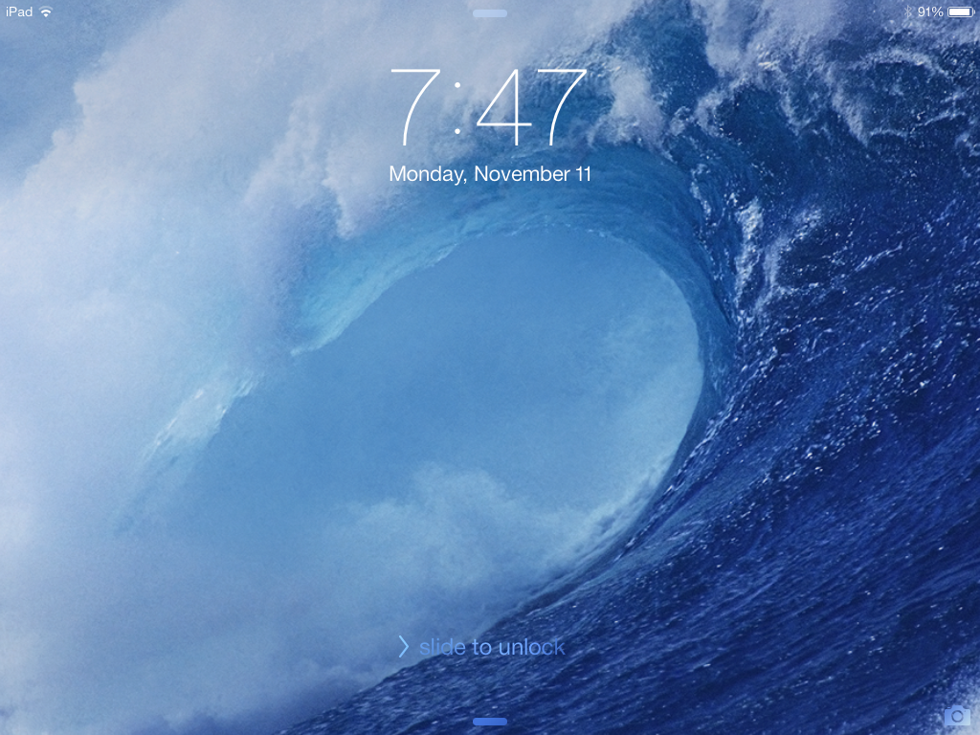
On/Off Button

    - Slide your finger over the “slide to unlock” text near the bottom of the screen from left to right, as indicated.
      - If the screen goes black at any time, press the round “Home” button to the left of the screen to bring it back.
    - You will be prompted to enter the 4-digit passcode.
      - This is the same code as the combination for the door of the SLYC office.
    - You should now see the iPad Home screen, which looks something like this:
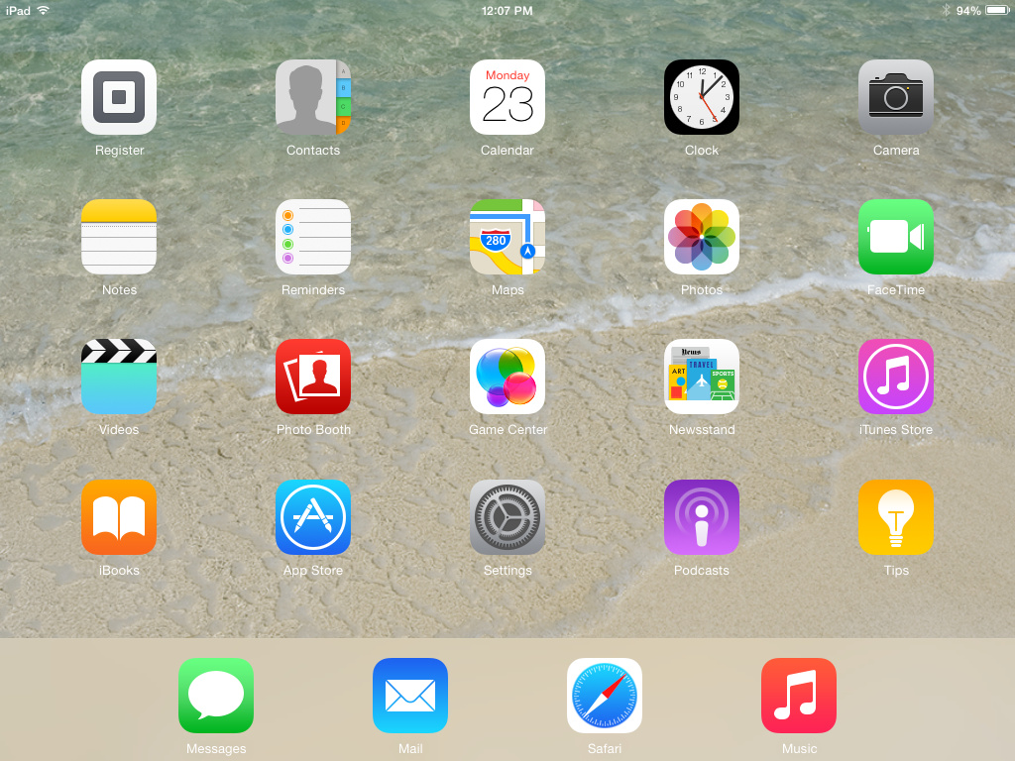

- Open the Square Register app and sign in
  - Touch the Square Register icon (it looks like the Square reader and has the word “Register” below it (it should be the upper left corner of the screen).
  - You should now see the Square register Sign-in screen:
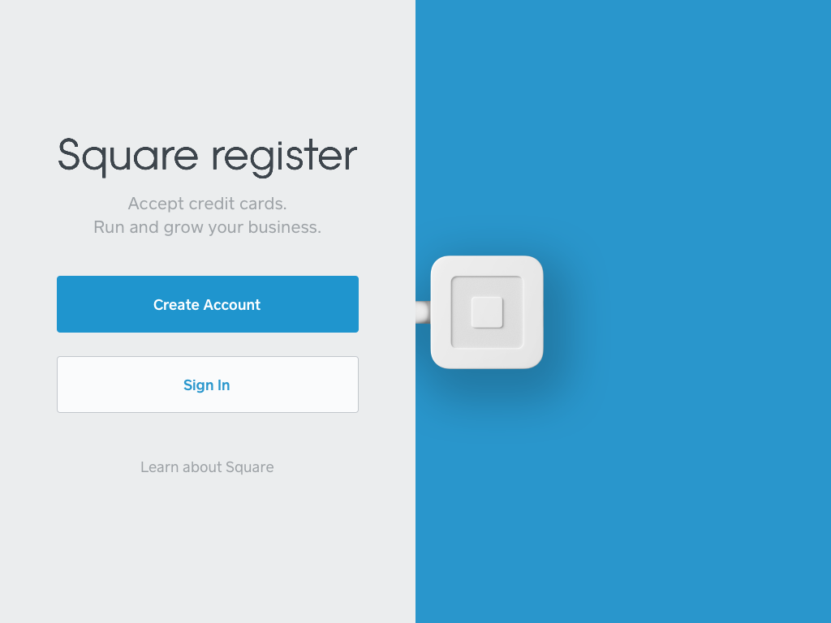
  - Touch “Sign In”
    - DO NOT attempt to Create a new Square Account.
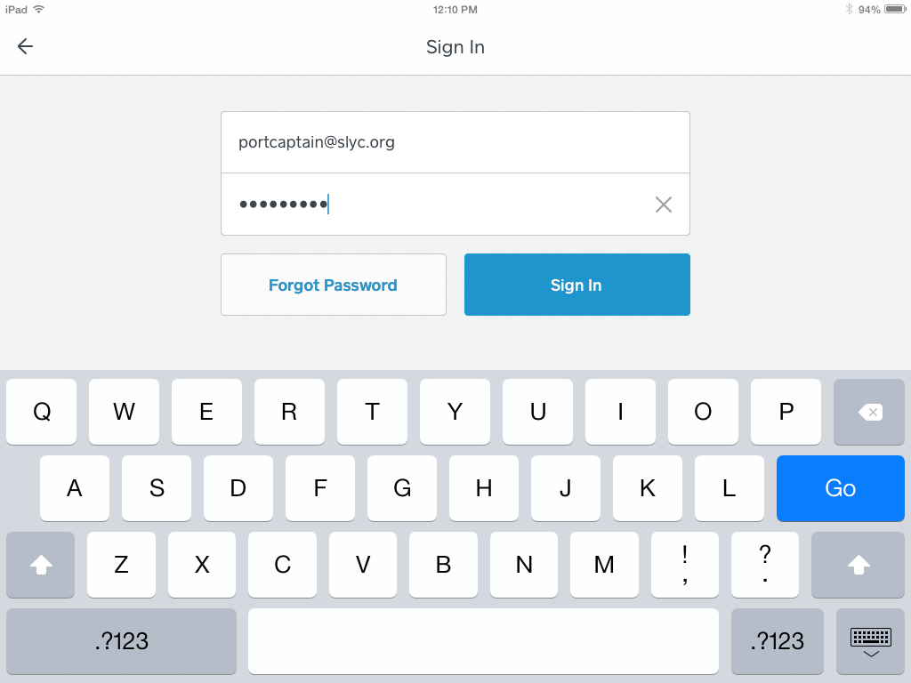
  - Enter the email address for your position on the board (portcaptain@slyc.org, for example), along with your own password (this is not the 4-digit code you entered earlier).
    - Alternatively, you may use the generic OD@slyc.org email address. The password for this email is the same as the password to access the Club’s WIFI, which is posted on the wall outside the galley.
  - Then touch “Sign In.”

  - You should now see a screen that looks similar to one of these next 4 screens (you can move between these menus by touching the tabs at the bottom of the screen):

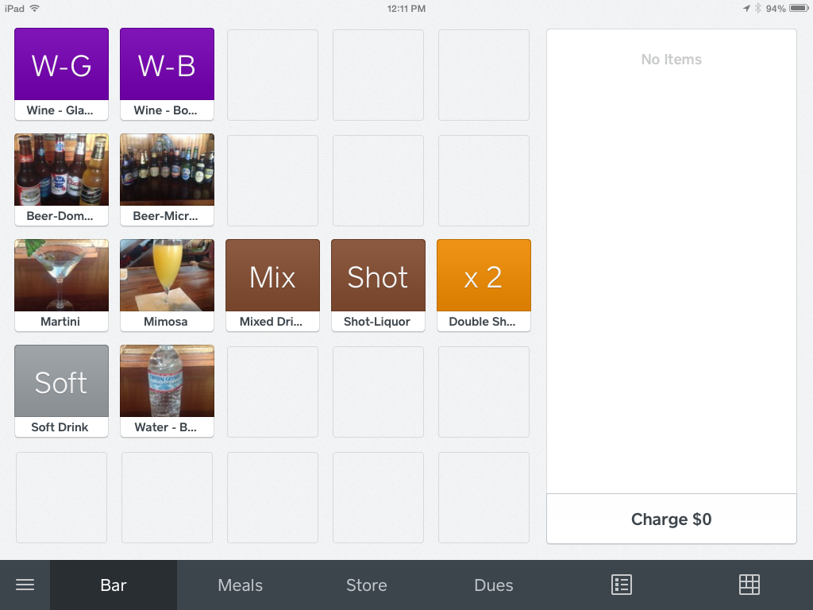
Bar Menu

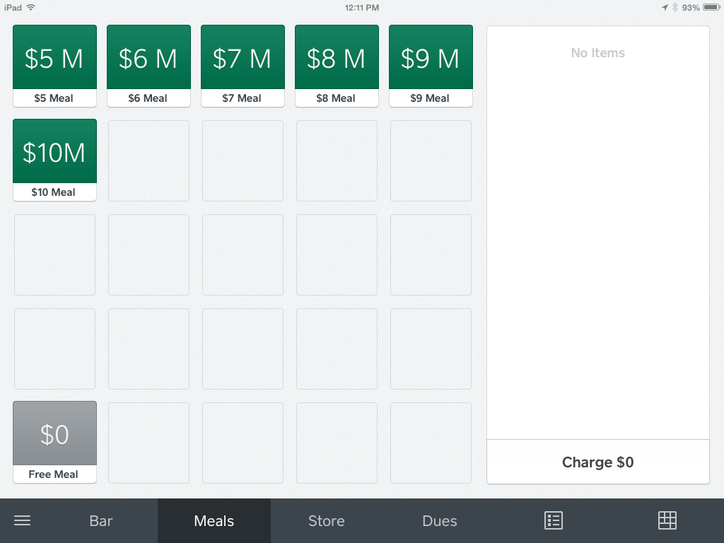
Meals Menu

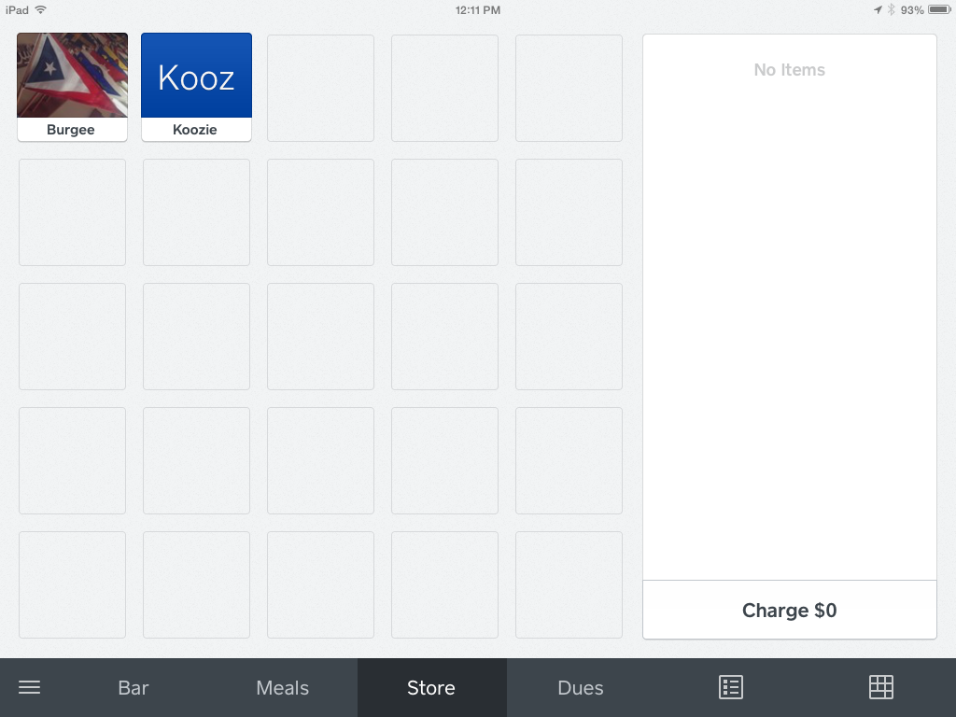
Ship’s Store Menu

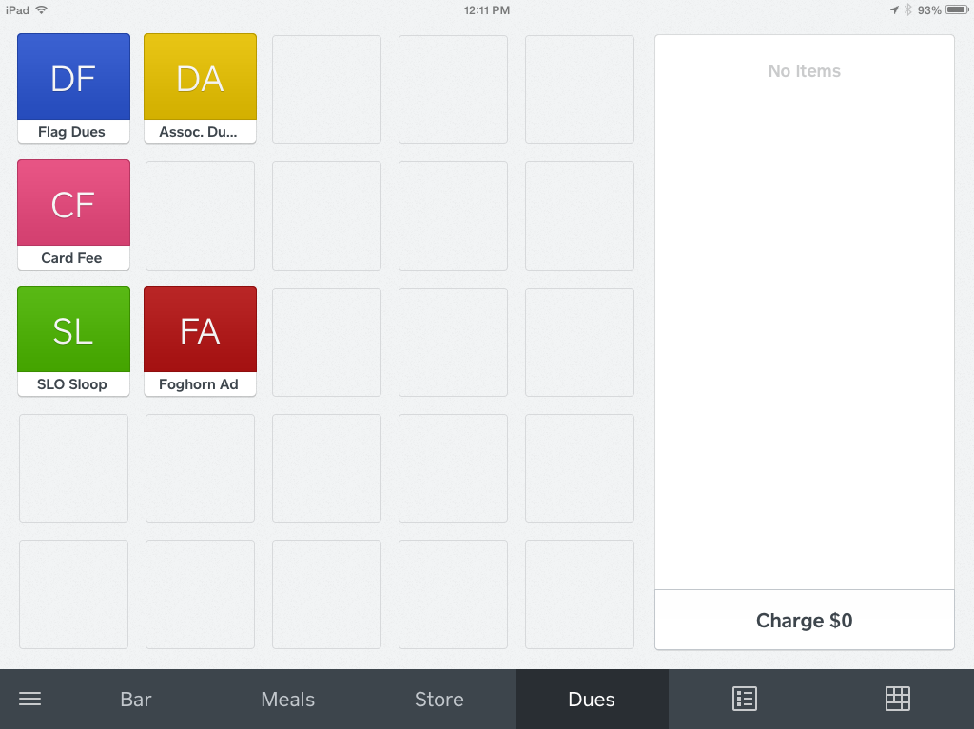
Dues Menu
- When you’re ready to open for business:
  - Plug the Square card/chip card reader into the earphone jack of the iPad.
    - If the iPad is oriented so the long edge is horizontal, the earphone jack will be on the upper-right corner of the iPad.
    - Make sure the iPad case is not obstructing your ability to fully insert the reader into the jack. None of the metal stem should be visible and the Square logo should be facing you.
  - Touch either “Bar,” “Meals,” “Store” or “Dues” at the bottom of the screen to display common items available for sale.
  - To ring up a sale, touch the item(s) being purchased
    - Touch an item multiple times for sales of more than one of any individual item.
    - You will see the item(s) listed and totaled on the right-hand side of the screen, like this:
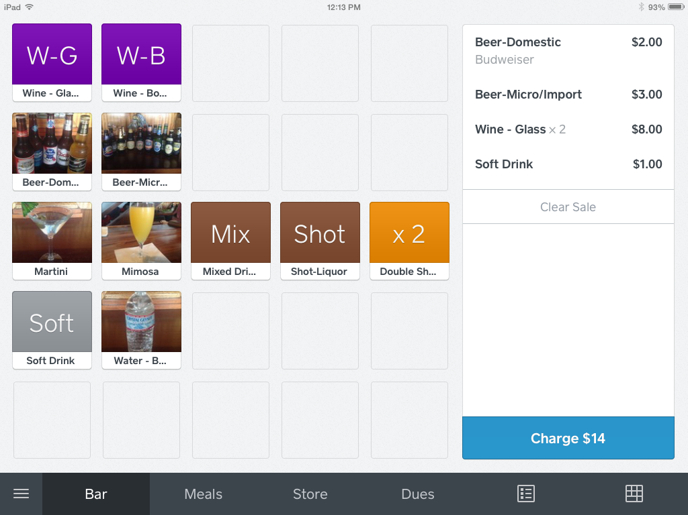
    - If the item is not listed on any of the menus touch the icon that looks like a 10-key pad in the lower right-hand corner of the screen and enter the amount manually.
      - “Custom Amount” will be displayed on the right side of the screen.
      - Touch the “Custom Amount” and a new screen will be displayed in which you can enter a description of the item in the “Notes and Quantity” section
      - Touch “+” or “-” if you need to adjust the quantity.
      - Touch “Save” to save the item(s) as part of your sale.
    - If you rang up an item by mistake, touch the item to bring up a detail screen of that item.
      - Scroll to the bottom and touch “Remove Item,” then “Confirm Remove Item.”
  - To void an entire sale before it’s charged to the card, touch “Clear Sale,” then “Confirm Clear Sale.”

  - When you have rung up all items for one customer, touch “Charge” in the lower right-hand corner.
    - For magnetic stripe credit cards, just swipe the card through rear slot in the card reader.
      - Swipe swiftly, making sure the magnetic strip is in the Reader facing the rear of the Reader (i.e., the front of the card is facing you).
        - You might have to swipe multiple times to get the Square Reader to successfully read the card.
          - Sometimes squeezing the Square Reader while swiping will help.
          - If the card won’t read after multiple tries, you can touch “Swipe or Enter Card Number” and enter the card number manually.
      - Try to avoid manually typing in the card number, if possible, because the fee charged by Square is higher if the card isn’t swiped.
    - For chip (“smart”) cards, insert the card into the front slot of the Reader, lining up the edge of the card with the guide on the left side of the Reader to ensure the Reader makes full contact with the chip.
      - Leave the card in this position until the transaction is completed.
    - At the end of the transaction ask the customer if he/she would like a receipt by email or text message.
      - If so, have them enter them enter their email address or 10-digit phone number.
    - When it tells you “You’re Done” it will return you to the screen for ringing up another sale. If it doesn’t take you back automatically there should be a “New Sale” button that will get you back to the screen for ringing up another sale.
    - If you touched “Charge” by mistake, touch the “X” in the upper left corner to get back to the previous menu.

- If you need to review a transaction (or possibly do a refund), touch the “3 horizontal bars” icon. The menu on the left side of the screen will look like this:
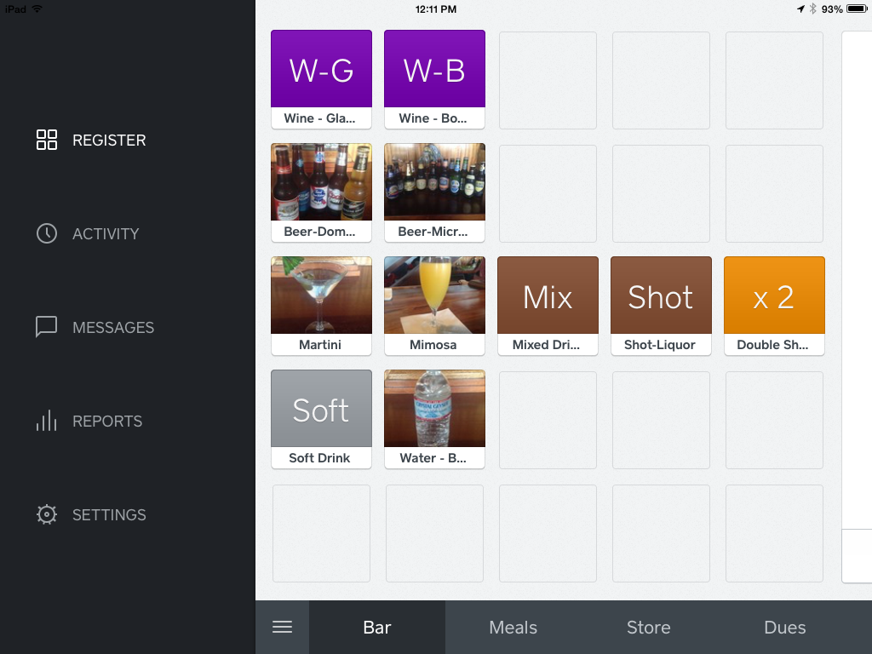
  - Select “Activity”
    - You will see several previous transactions (in reverse chronological order).
    - When you find the transaction in question, touch it to select it. Then you can review it for accuracy, refund it or send another receipt.
  - You can view a summary of the day’s activity—or of previous days’ activity—at any time by touching the “Reports” menu, then “Sales Summary.”
    - Touch the icon that looks like a spreadsheet (at the top of the screen) for more detail.
  - To go back to ringing up sales, touch the “3 Horizontal Bars,” then “Register.”

- When you’re ready to close out for the day, from the “3 Horizontal Bars” menu touch “Settings.”
  - You’ll have to enter the 4-digit code again.
  - Scroll to the bottom of the list on the left-hand side of the screen.
  - Touch “Sign Out” and Confirm Sign Out.”
  - Press the round “Home” button in the iPad (not on the screen) to return to the iPad Home screen.
  - Turn off the iPad.
    - The on/off button is located near the lower-right corner of the iPad (same side as the Square reader).
    - Press and hold the on-off button for a few seconds—until “slide to power off” appears near the top of the screen.
    - Slide your finger to the right over the “slide to power off” display.
    - Return the iPad and Square reader to the safe.
    - You’re done!
      - No need to record your credit card sales on the cash envelope. Square will automatically send a report of your credit card activity to the SLYC Treasurer and the funds will be deposited into our checking account.

