Prior to sailing “Second Wind,” all SLYC Members must first: complete an orientation and checkout sail with designated member of the Boat Committee, pay the annual fee, sign a copy of the Club’s current Boat Use Agreement and Orientation Guidelines, and reserve the boat through the Club’s website.

After your checkout sail and boat orientation, the Boat Committee will assign or rate each member as skipper or sailor- (Level A or B). Level A Sailors have unrestricted use of the Second Wind, within the guidelines and restrictions described in the Use Agreement. Level B sailors must have a SLYC Skipper or another Level A or B Sailor aboard until they demonstrate appropriate skills & procedure adherence. The Boatmaster can provide a list of current skippers. Level B sailors should use the Orientation Guidelines as a “checklist” until “Level A” proficiency is assigned by the Boat Committee.

Any Skipper sailing “Second Wind” is responsible for the safety of the vessel and all crew. Bring a working handheld VHF radio and know how to use it. Port San Luis Harbor Patrol monitors VHF channels 12 and 16 only. Remember, Channel 16 is reserved for emergency use only. Bring a cell phone to contact the Water Taxi. The Water Taxi phone number is 805-305-4796. Bring personal floatation devices for any children, X-Small, or XXXL passengers. Do not depart the mooring without a VHF radio. A portable G.P.S. device is suggested in case of fog. Boat shoes or nonslip and non- marking shoes are required for all.

- After boarding, secure the life-line gates. Take a moment to inspect how the bird netting is installed before you remove it and stow it below. Remember, you will have to in-reinstall it before you leave the boat.
- Remove the companionway canvas cover, unlock and remove the three companionway boards, slide the hatch forward, and stow the boards in the canvas holder underneath the companionway steps. Stow the padlock in the nav table. The main sail cover is a permanently installed “Stack-Pak”. Do not remove it. Simply open the full-length zipper on top of the Stack-Pak so the main sail can be raised. Remove nose piece, or apron, at front of the Stack-Pak and stow it below. Remove the canvas helm cover, fold and stow below. If you wish to use the white vinyl cockpit cushions bring them up and snap down any snaps. Begin logbook entries for day. Retrieve engine key. Inspect the rigging for issues.
- Turn the battery selector on the panel above nav station to “Both”, and check voltage level on the batteries (it should read at least 12.6 V for both). Check the bilge for excess water, if there is more than one inch of water in the bilge, run the bilge pump manually to reduce the level, and report the condition to the Boatmaster. Review the inventory sheet for the complete list of equipment onboard, and the location where the equipment is stowed
- Clean any bird poop off boat. Organize and prepare the running rigging for sailing.
- Brief all crew on safety procedures such as: staying aboard the boat, crew overboard procedures, starting the engine, calling for assistance, use of the anchor if disabled, etc.
- Instruct all crew on the proper use of the head. (No paper is to be put in the head. Use the trash can provided.)
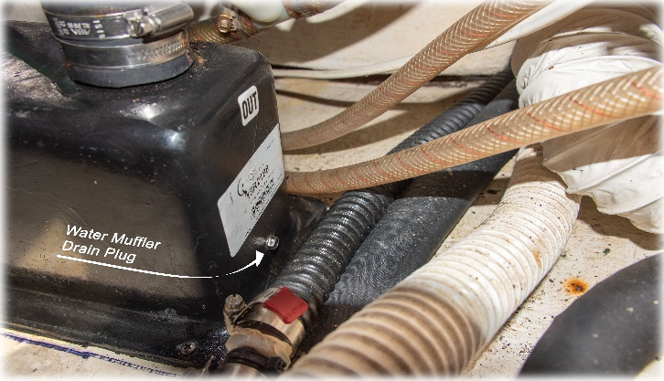
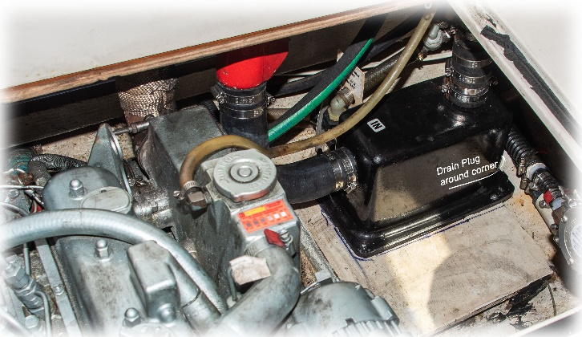
- Starting the Engine: insert engine key in the ignition located on the starboard side of instrument pod and turn it forward one notch and check fuel gauge. Do not depart if diesel fuel is less than ¼ tank. Report the fuel level to the Boatmaster if less than 1/3 tank. Make sure the engine stop “T” handle is fully down, the shift lever is centered in neutral, and the throttle is all the way back at minimum. Turn the ignition key forward against spring resistance to the second notch and hold it there for about 20-30 seconds to warm the glow plugs, then depress start button. If engine doesn’t start in 10 seconds, STOP cranking and re-apply glow plugs as described above. If the engine doesn’t start after 30
seconds total cranking time, the waterlift muffler MUST be drained before continuing or engine will be seriously damaged. There is a drain bolt located on the lower edge of the water lift muffler, on its portside, that must be removed to drain the muffler, then reinstalled. (qualified users must be familiar with this procedure). Once the engine starts, you may increase the rpms to 1000-1200 for a few moments to warm the engine. To STOP the engine, return throttle to idle, move the gear selector to neutral, then pull up on the stop “T” handle (it’s a little stiff so pull hard). NEVER turn the battery selector to the off position, or turn the key off while engine is running, as this will damage the alternator. After the engine has stopped, push the T handle back down. Otherwise the engine will not restart.
- Record the engine hours and the fuel gauge reading in logbook before departing. Loosen wheel tension knob on starboard side of the helm, and make sure the autopilot lever is in the off position, so the helm turns freely. Locate the amid ship tape marker on wheel so you can identify when the rudder is centered. After the engine warms up, you may release the mooring bridle and chain. Allow the boat to drift away from the mooring and its lines before putting the boat in gear to avoid fouling the prop in the mooring line. Please use the engine sparingly and keep tachometer below 2000 indicated. The actual engine RPMs are much higher than the reading you see on the tachometer. A tachometer calibration card is located in the nav desk which will show you actual engine RPMs based on the reading you see on the tachometer. You may wish to mark the mooring with the “pickup poles” stored in the aft berth.
- Enjoy Safe Sailing. If the wind begins to increase, reef earlier rather than later. When sailing, keep the transmission selector in reverse. Second Wind has a folding prop, so response is initially slower when the boat is shifted into reverse.
- Keep the boat away from “lee” shores and other hazards such as heavy kelp and floating debris. Use of Second Wind is limited to a ten-mile radius of the Club House, unless prior written permission is received from the Boatmaster.

Please also reference “Club Boat Use agreement,”, “Second Wind Inventory List”, and “Returning to Mooring Orientation Guidelines.”

SLYC Member Name:

Signature: Date: .

