If you are relying on the Water Taxi, you must carefully PLAN your return to allow enough time to properly secure the boat and work with the Water Taxi’s schedule

You may do some of the cleaning and stowing procedures ahead of your return to mooring to speed completion.

- Start the engine (see sailing directions) and steer into the wind. Furl the Jib until the sheets wrap at least three times around the furled sail. Remove slack from the jib sheets and secure them to the winches. Lower the mainsail into “Stack Pak.” Assign crew to bow duty and instruct them on hand signals, communication, and procedures for picking up the mooring.
- After lowering the mainsail, remove the main halyard shackle from head of mainsail and attach it to the handrail on the starboard side of the coach roof via a short loop of rope that is tied to the handrail. Pull the main halyard hand tight and close the jam cleat. Make sure the mainsail is neatly flaked and secure in “Stack-Pak,” and zip up the cover, and replace and secure nose or apron canvas on forward part of “Stack-Pak”.
- Center the traveler, tension the topping lift and the mainsheet to secure the boom and minimize it from swinging. Organize and secure all other running rigging and close all line clutches.
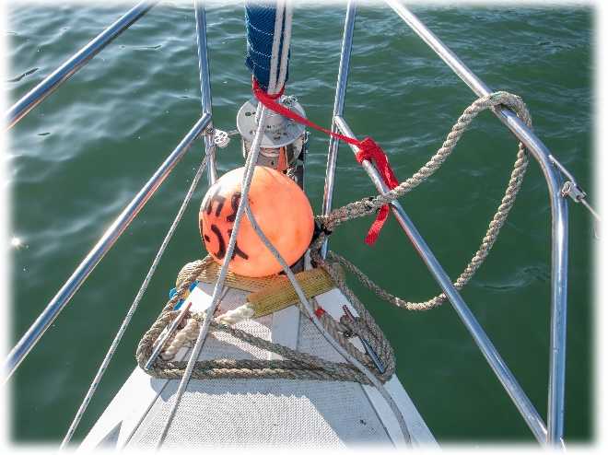
- Approach the mooring motoring slowly from downwind, and pick up the mooring ball and pendant with the boat hook, or the pole buoy (if used). Pull the mooring pendent up until the bridle is reached. Attach the two bridle loops to the bow cleats so they cross the bow and the chafe guards ride on the boat. Pass the mooring ball beneath the bow pulpit rails and run the pendent over the anchor roller. Excess slack in the pendent can be wrapped around the bow cleats for added security. The mooring is also equipped with an additional bow chain. Attach this chain to the bow ring below the anchor roller with a heavy stainless-steel carabiner. This chain is designed to take the load before the bridle in order to minimize chaffing.
- Shut-off the engine by pulling the “T” lever located on the Port side of the cockpit, not by turning key off. Push the “T” lever fully back down after the engine comes to a complete stop. Note the engine hours and fuel level in the Captain’s Logbook. Remove engine key and stow in the nav table. Turn the battery switch above the nav desk to “All Off”, and turn all breakers off.
- Close all the hatches, and dry and return all gear, PFDs, etc., to their proper places. Leave the head in clean and fresh condition with the through hull valve closed. Remember to close the propane cylinder valve if you opened it.
- Dry the cockpit cushions and return them to the aft berth. Stow the seat cushions on edge to avoid mildew developing on the cushions.
- Complete your Captain’s Log entry with any comments. Notify the Boatmaster asap if any issue will prevent or impede use of the boat. (DO NOT CLOSE ENGINE COOLING WATER INTAKE SEACOCK)
- Tighten the helm friction brake located on the starboard side of the binnacle, and replace the cover on the helm/binnacle. Close and secure all hatches, companion way, lazarettes, lockers, and settees.
- Remove trash and put new liner bags in the trashcans. Remove any perishable food, wet towels, etc. Clean any mess in or on the boat, galley, head, cockpit, etc. The boat should be left as clean or cleaner than when you arrived.

Nonperishable “provisions” left on board that are not specially marked as Club, emergency, or special event supplies are “fair game”, and you may consume what you find aboard and so may any other crew. Feel free to leave unopened shelf stable food and drink. No open red wine should be below deck. Open any red wine and keep it above deck to prevent stains from spills.

- Make sure all galley dishes, glasses, cutting boards, utensils, trays, etc., are clean, dry and stowed in proper places.
- Replace and secure the bird netting and the canvas cover on the companion way, and the binnacle. Secure the lifeline gate as you leave the boat.

You may now schedule another sail on club website .

Please also reference “Club Boat Use agreement,”, “Second Wind Inventory Sheet”, and “Before You Sail Orientation Guidelines”

SLYC Member Name:

Signature: Date: .

