WARNING:
Boating in the waters near Points Arguello and Conception is inherently dangerous! Navigation in these waters requires advanced training, extensive experience in marine boating, and extraordinary preparation and planning. Nothing in this program is intended to entice any boater who lacks sufficient training, experience and preparation, or the use of any vessel not capable and fully prepared for such a voyage to attempt this hazardous activity. Recognition of the achievement of this voyage by highly qualified boaters and vessels is designed, in part, to create awareness that the sport of marine boating in general, and especially in more challenging areas, requires dedication to safety and ongoing acquisition of the skills of seamanship.
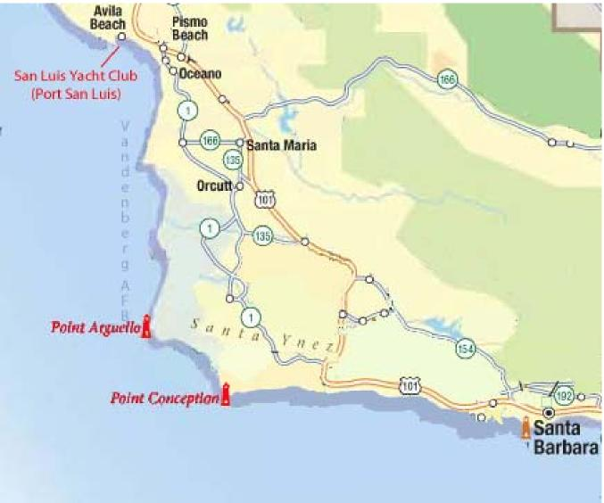

INTRODUCING . . .
THE POINTS ARGUELLO AND CONCEPTION
NAVIGATION AWARD PROGRAM
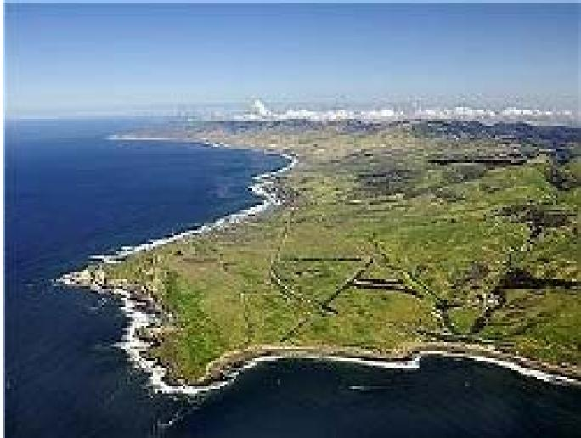
A Recognition Program for Skilled Coastal Mariners
Sponsored by
The San Luis Yacht Club
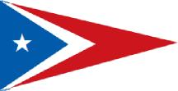
(Member, Southern California Yachting Association)
THE SAN LUIS YACHT CLUB
POINTS ARGUELLO AND CONCEPTION NAVIGATION AWARD PROGRAM
Ever since the days of Juan Rodríguez Cabrillo, the first European sailor to explore the California coast, the waters around Points Conception and Arguello have been recognized as a formidable challenge. It was for ample reasons that ancient Spanish mariners referred to this area as “la Mandibula del Diablo” – “the Devil’s Jaw.” Most of those who successfully round these points today agree that the north-bound leg is the more difficult. Even the most experienced mariners do well to research and plan carefully before attempting this hurdle. But rounding the “Cape Horn of the West” is necessary for all those seeking to cruise the length of California’s beautiful coast.
The San Luis Yacht Club is located in the first working port north of Point Arguello, in beautiful Avila Beach. We have established a special award program for members of reciprocal yacht clubs to recognize the significant accomplishment of a successful north-bound voyage around The Points.
The Points Arguello and Conception Navigation Award Program is intended to:
- Create awareness that the sport of marine boating in general and especially in more challenging areas requires dedication to safety and ongoing acquirement of the skills of seamanship.
- Recognize achievement of this voyage by highly qualified boaters and vessels capable of such an undertaking safely.
- Encourage members of reciprocal yacht clubs to visit Port San Luis and the San Luis Yacht Club as a part of their coastal voyage.
Avila Beach – Port San Luis
Our home port is one of the most desirable Ports of Call on the California Coast! Avila Beach - Port San Luis offers great food, motel accommodations, and convenient access to local wine country, entertainment, and other attractions. Port San Luis offers fuel, a work dock with electric and water, marine mechanics, and overnight orders for boat parts not immediately available at Port San Luis. Mooring and Anchorage is readily available, and dinghy dockage is convenient.


Eligibility:
Each crew member (including the captain) who are members of reciprocating yacht clubs who successfully completes a northbound voyage around Points Arguello and Conception on or after 1 April 2013, and immediately thereafter anchors or moors in Port San Luis are eligible to:
- Receive a certificate of recognition for successfully completing the voyage.
- A hot shower in the San Luis Yacht Club clubhouse.
- A complimentary beverage (age appropriate) at the San Luis Yacht Club clubhouse.
- En route or upon arrival in Port San Luis, immediately after successfully rounding Points Arguello and Conception, crew members must contact the San Luis Yacht Club Port Captain or his designee. A phone number is posted on the message board in front of the Clubhouse, and full contact information is available on the San Luis Yacht Club website:
http://slyc.org/Board/officers.html
- Crews must complete a questionnaire and sign the Program Log. Information gathered on voyages will be used to assist future mariners in successfully accomplishing the voyage.
- The captain of the vessel will be presented with one trophy flag for the vessel. Additional trophy flags may be purchased from SLYC by crew members of the vessel.
