Short-Form Instructions for Using the Square Register
(Used for ringing up credit card sales)
Revised February 2015

- Turn on the iPad.
- Enter the 4-digit pass code (same code as the combination for the door of the SLYC office).
- Open the Square Register app and sign in with your SLYC position email address and your personal password.
- Plug in the Square card reader.
- Begin ringing up sales.
- When you’re ready to close out for the day, sign out of Square register.
- Turn off the iPad.

Detailed Instructions for Using the “Square Register”
(Used for ringing up cash, check and credit card sales)

- Getting started with the iPad
  - The iPad Mini and Square card reader are stored in the safe in the liquor closet.
  - Turn on the iPad.
    - Orient the iPad so the long edge is horizontal and the earphone jack is on the upper-right corner of the iPad.
    - The on/off button will now be located on the edge of the iPad, near the lower-right corner.
    - Press and hold the on-off button for a few seconds—until the Apple logo appears in the center of the screen.
    - When the Apple logo disappears the screen should look like this:
Square Reader plugs in here
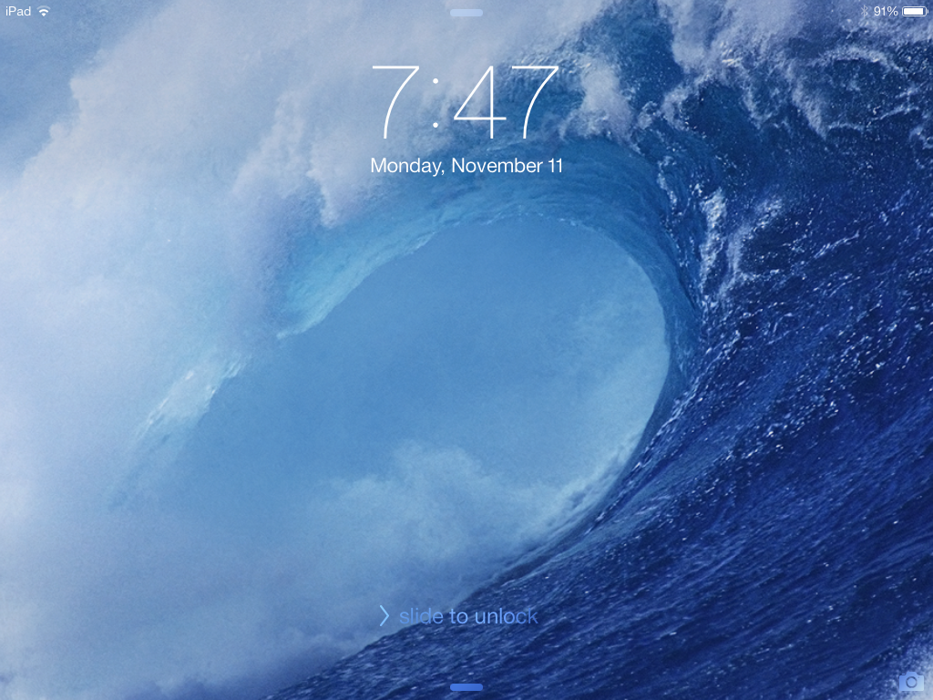
On/Off Button

    - Slide your finger over the “slide to unlock” text near the bottom of the screen from left to right, as indicated.
      - If the screen goes black at any time, press the round “Home” button to the left of the screen to bring it back.
    - You will be prompted to enter the 4-digit passcode.
      - This is the same code as the combination for the door of the SLYC office.
    - You should now see the iPad Home screen, which looks something like this:
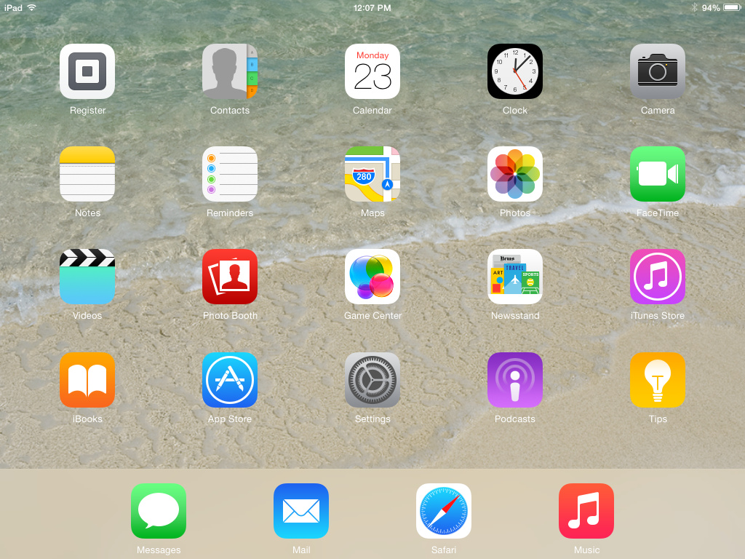

- Open the Square Register app and sign in
  - Touch the Square Register icon (it looks like the Square reader and has the word “Register” below it (it should be the upper left corner of the screen).
  - You should now see the Square register Sign-in screen:
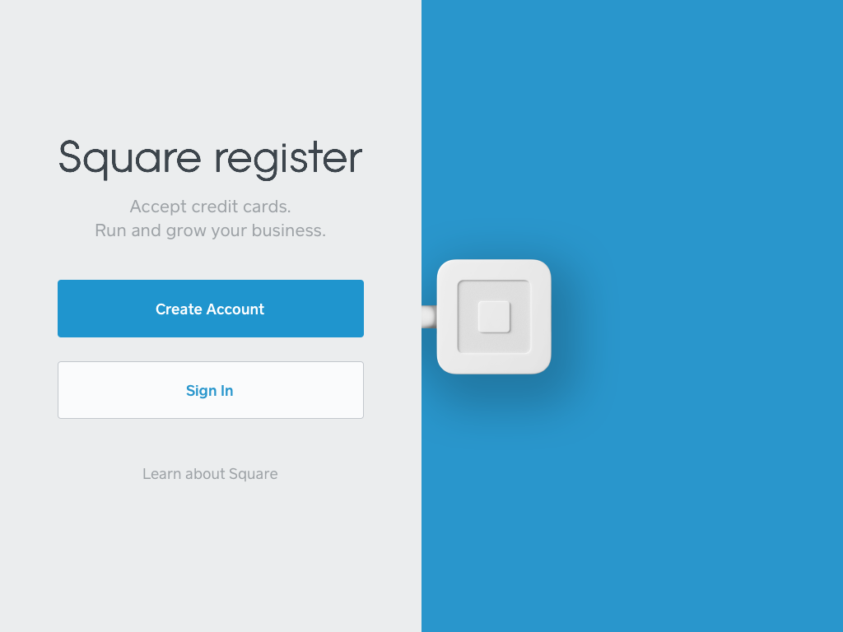
  - Touch “Sign In”
    - DO NOT attempt to Create a new Square Account.
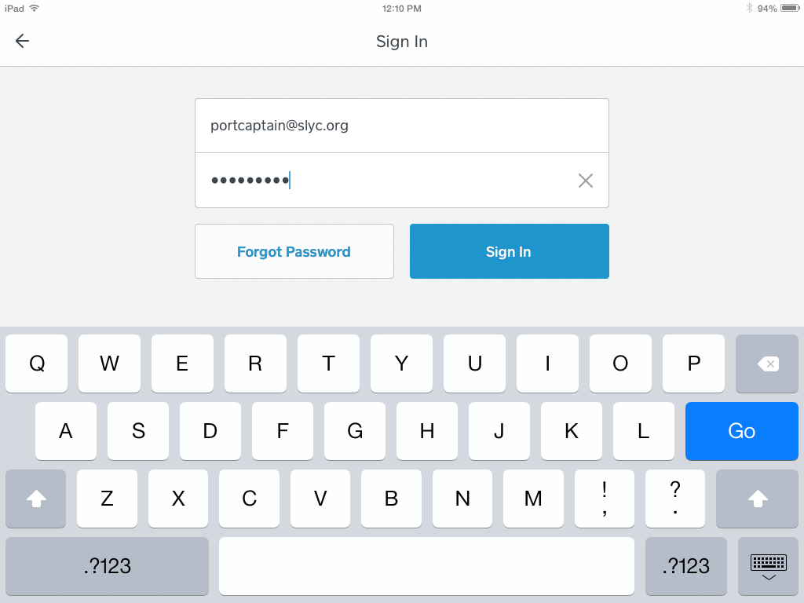
  - Enter the email address for your position on the board (portcaptain@slyc.org, for example), along with your own password (this is not the 4-digit code you entered earlier).
  - Then touch “Sign In.”

  - You should now see a screen that looks similar to one of these next 4 screens (you can move between these menus by touching the tabs at the bottom of the screen):

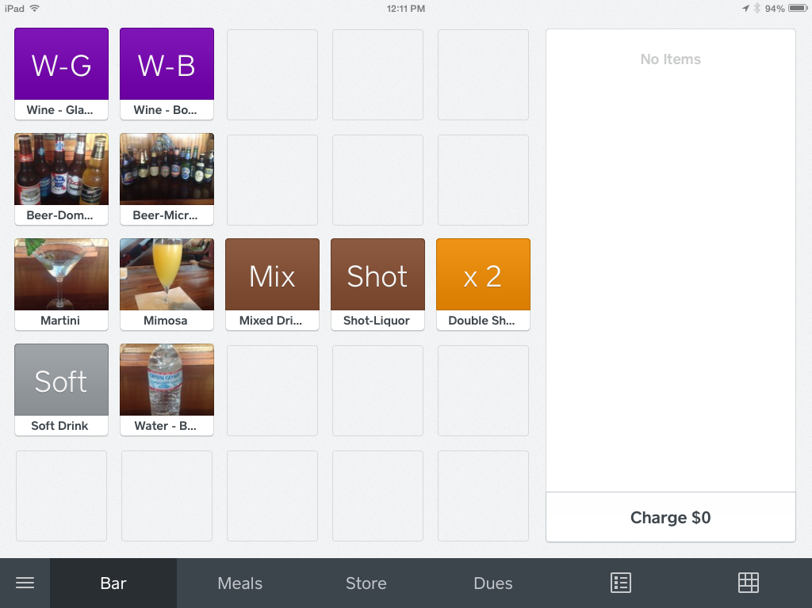
Bar Menu

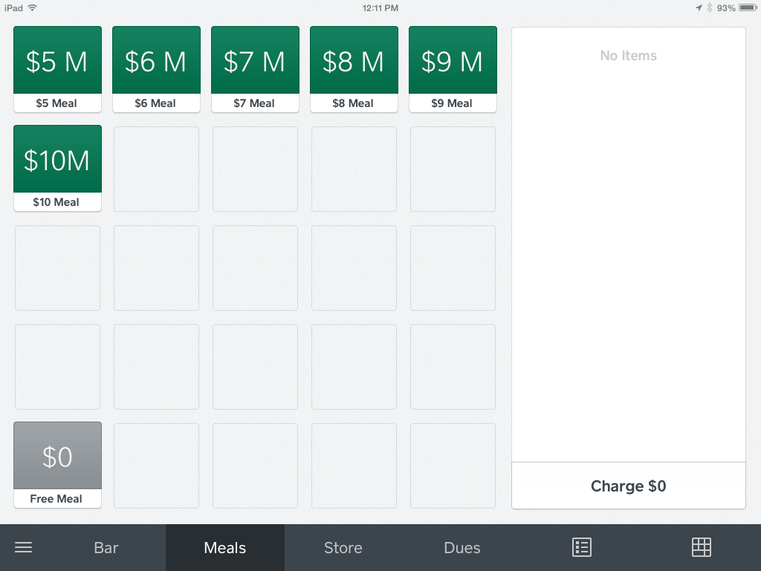
Meals Menu

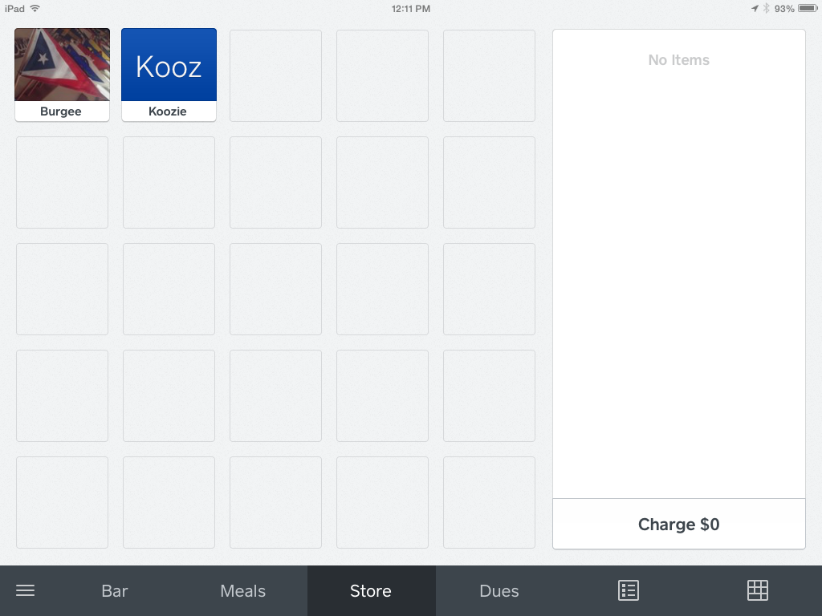
Ship’s Store Menu

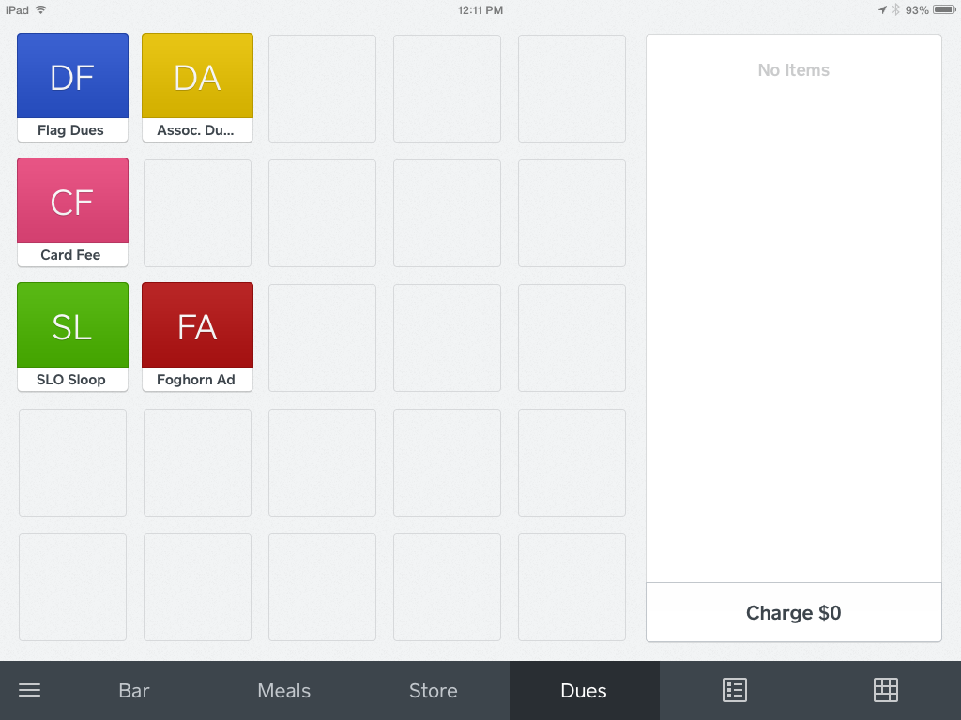
Dues Menu
- When you’re ready to open for business:
  - Plug the Square reader into the earphone jack of the iPad.
    - If the iPad is oriented so the long edge is horizontal, the earphone jack will be on the upper-right corner of the iPad.
    - Make sure the iPad case is not obstructing your ability to fully insert the reader into the jack. None of the metal stem should be visible and the Square logo should be facing you.
  - Touch either “Bar,” “Meals,” “Store” or “Dues” at the bottom of the screen to display common items available for sale.
  - To ring up a sale, touch the item(s) being purchased
    - Touch an item multiple times for sales of more than one of any individual item.
    - You will see the item(s) listed and totaled on the right-hand side of the screen, like this:
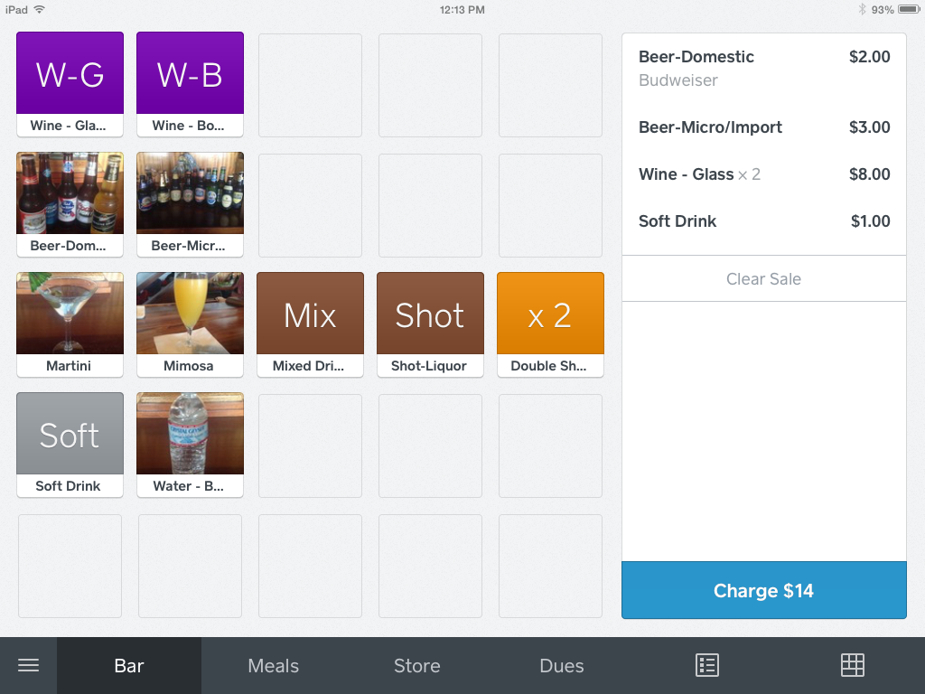
    - If the item is not listed on any of the menus touch the icon that looks like a 10-key pad in the lower right-hand corner of the screen and enter the amount manually.
      - “Custom Amount” will be displayed on the right side of the screen.
      - Touch the “Custom Amount” and a new screen will be displayed in which you can enter a description of the item in the “Notes and Quantity” section
      - Touch “+” or “-” if you need to adjust the quantity.
      - Touch “Save” to save the item(s) as part of your sale.
    - If you rang up an item by mistake, touch the item to bring up a detail screen of that item.
      - Scroll to the bottom and touch “Remove Item,” then “Confirm Remove Item.”
  - To void an entire sale before it’s charged to the card, touch “Clear Sale,” then “Confirm Clear Sale.”

  - When you have rung up all items for one customer, touch “Charge” in the lower right-hand corner.
    - For credit card sales, just swipe the card through the card reader.
      - Swipe swiftly, making sure the magnetic strip is in the Reader, facing the thicker side of the Reader.
        - You might have to swipe multiple times to get the Square Reader to successfully read the card.
          - Sometimes squeezing the Square Reader while swiping will help.
          - There should be two Square Readers in the safe. If you’re having trouble with one, try using the other one.
          - If the card won’t read after multiple tries, you can touch “Swipe or Enter Card Number” and enter the card number manually.
      - Try to avoid manually typing in the card number, if possible, because the fee charged by Square is higher if the card isn’t swiped.
    - At the end of the transaction ask the customer if he/she would like a receipt by email or text message.
      - If so, have them enter them enter their email address or 10-digit phone number.
    - When it tells you “You’re Done” it will return you to the screen for ringing up another sale. If it doesn’t take you back automatically there should be a “New Sale” button that will get you back to the screen for ringing up another sale.
    - If you touched “Charge” by mistake, touch the “X” in the upper left corner to get back to the previous menu.

- If you need to review a transaction (or possibly do a refund), touch the “3 horizontal bars” icon. The menu on the left side of the screen will look like this:
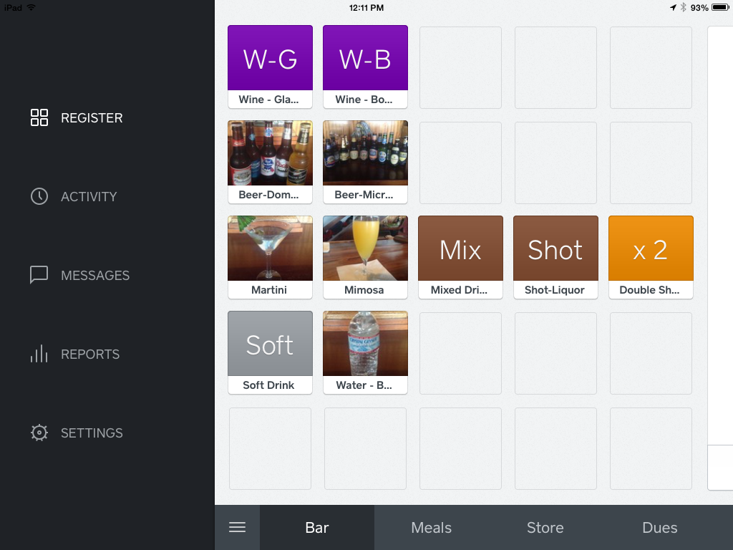
  - Select “Activity”
    - You will see several previous transactions (in reverse chronological order).
    - When you find the transaction in question, touch it to select it. Then you can review it for accuracy, refund it or send another receipt.
  - You can view a summary of the day’s activity—or of previous days’ activity—at any time by touching the “Reports” menu, then “Sales Summary.”
    - Touch the icon that looks like a spreadsheet (at the top of the screen) for more detail.
  - To go back to ringing up sales, touch the “3 Horizontal Bars,” then “Register.”

- When you’re ready to close out for the day, from the “3 Horizontal Bars” menu touch “Settings.”
  - You’ll have to enter the 4-digit code again.
  - Scroll to the bottom of the list on the left-hand side of the screen.
  - Touch “Sign Out” and Confirm Sign Out.”
  - Press the round “Home” button in the iPad (not on the screen) to return to the iPad Home screen.
  - Turn off the iPad.
    - The on/off button is located near the lower-right corner of the iPad (same side as the Square reader).
    - Press and hold the on-off button for a few seconds—until “slide to power off” appears near the top of the screen.
    - Slide your finger to the right over the “slide to power off” display.
    - Return the iPad and Square reader to the safe.
    - You’re done!
      - No need to record your credit card sales on the cash envelope. Square will automatically send a report of your credit card activity to the SLYC Treasurer and the funds will be deposited into our checking account.

