Brittany Tomasko

High Priority
- Beams/Fans
- Coffeebar
- Fireplace/Bricks
- Flags/Flagpoles
- Ships Above the Bar
- Tables/Chairs

Moderate Priority
- Benches
- Glass Cabinets
- Floorboards
- Floors Linoleum
- Stairs to Attic
- Windows/Sills

Low Priority
- Attic
- Bar Foot Rail
- Broom Closet
- Chair Cabinet
- Trophy Case
- Walls

Sandy Gillespie

High Priority
- Kitchen Cabinets
- Refrigerator/Freezer
- Stove/Oven

Moderate Priority
- Butcher Block
- Glassware
- Kitch. Upper Storage
- Liquor Closet
- Merchandise Display

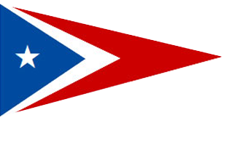

Bob Hurd

High Priority
- BBQ
- Mats (Door & Bar)

Moderate Priority
- Outside Tables/Chairs
- Windows on Deck

