SLYC Reservation Calendar
1-27-18

Note: The club calendar consists of 4 separate calendars; Cruising | Racing | SLYC Events | Reservation, as shown below (you can see them by clicking on the little downward triangle) You can show or hide each calendar by clicking on the checkmark box.

So, when entering reservations, avoid entering ‘club events’ such as orientation, interviews, Hobie races, etc., as these are not reservations but rather SLYC sponsored Events. Notify the webmaster if SLYC sponsored events are needed in the calendar (or edited)
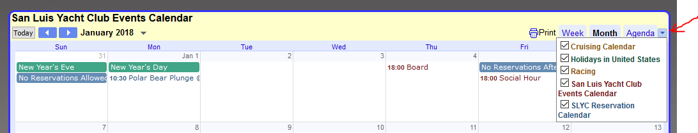

- Click on , located in bottom right of calendar
- Sign-in screen pops up, requiring sign-in. You have three choices [see Figure 1]
  - Use your existing google email & password, or
  - Click on 'Create an account' and establish a gmail, or
  - Click on 'Create an account' and use an existing email
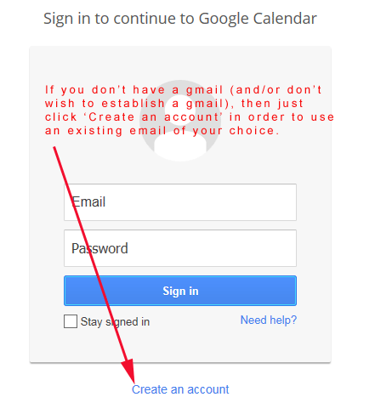
Figure 1
- After selecting Create an account This screen (See Figure 2. - partial screen shown) pops up when you select 'Create an account'. If you wish to use an existing non-gmail address, then select 'I prefer to use my current email address' as shown below, and the @gmail.com will disappear so you can enter your desired email address.
Continue filling out the form (See Figure 3 for remainder of form)
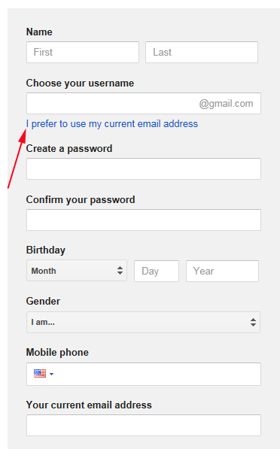
Figure 2
Bottom half of above form
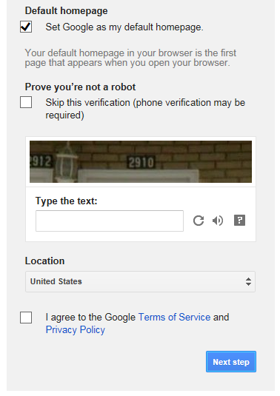
Figure 3
- Next, the calendar pops up (partial view below) [see Figure 4]
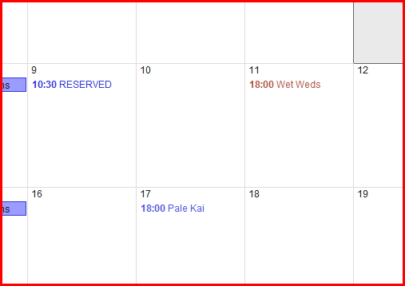
Figure 4
- Navigate to the date desired (we'll use the 10th) and left click inside the date box. The event|Task popup will appear. [see Figure 5]
  - Make sure the Calendar field says SLYC Reservation Calendar. You will note it came up with Michael Dobrzensky google calendar (based on my personal login)
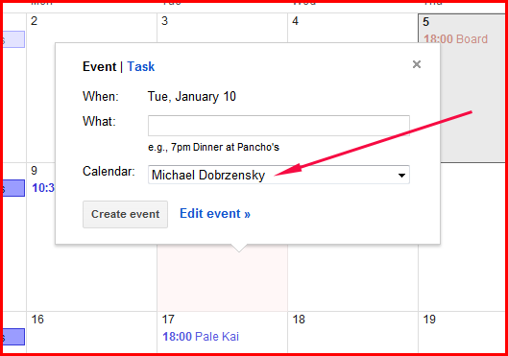
Figure 5

- Click in the Calendar field and select SLYC Reservation Calendar
- Then click Edit event. [see Figure 6]
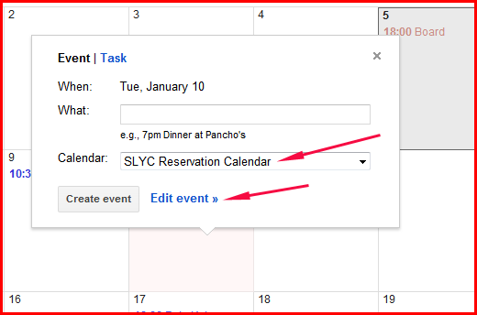
Figure 6

- Clicking on Edit event brings up the following entry screen: [see Figure 7]
  - Enter Reserved and Name in the Untitled event box, or
  - Enter T Reserved and Name for tentative reservations not yet approved by the BoD
  - Enter a description under 'Description', as appropriate. Typical entry:
Reserved Lorie Norkus
Galley YES
Alcohol YES 4pm - 7pm
BBQ NO
Bar NO
Pro Security YES
Pro Cleaning YES
Approved by BOD 9/3
  - Deselect 'All Day', which will bring up the date boxes [see Figure 8]
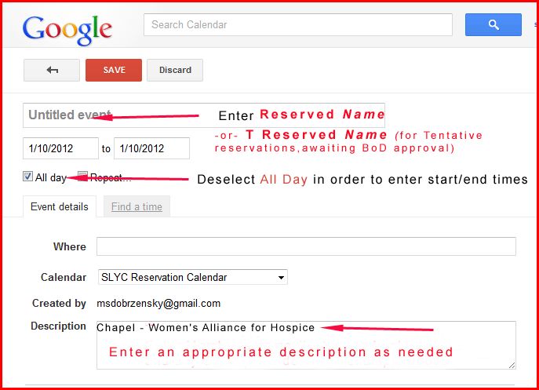
Figure 7
- Enter start and completion times for the desired date (Figure 8)
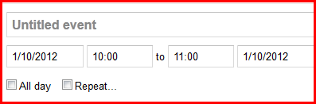
Figure 8
- Then select - you will be returned to the calendar. Make sure the reservation entered is in the date desired, shows up in blue lettering (the color for the reservation portion of calendar, and says SLYC Reservation Calendar

