SLO Sloop Reservation Calendar
4-26-2013
This procedure details how to (A) sign up for a Google account, (B) sign-in, and finally to (C) make entries into the calendar. Users must have a Google account or Gmail in order to sign-in and make entries into the online 'SLO Sloop Reservation Calendar'.
You do not have to have Gmail. You will either sign-in with your existing Gmail account info, or with your existing email with a password you establish when setting up the Google account. The password is independent from the password you use with your personal email account

Contents:
A. Sign-up for a Google Account
B. Sign-in to the Google Calendar to make entries
C. Making entries in the Calendar

If you have an existing Gmail, then skip to: B. (Sign-in to the SLO Sloop Calendar)

A. Sign-up for a Google Account

The SLO Sloop Reservation Calendar is located on the SLYC website at slyc.org/SLO_Sloop_Cal.html and looks similar to [Figure A]:
(there is a link to the calendar at the bottom of the SLYC home page)

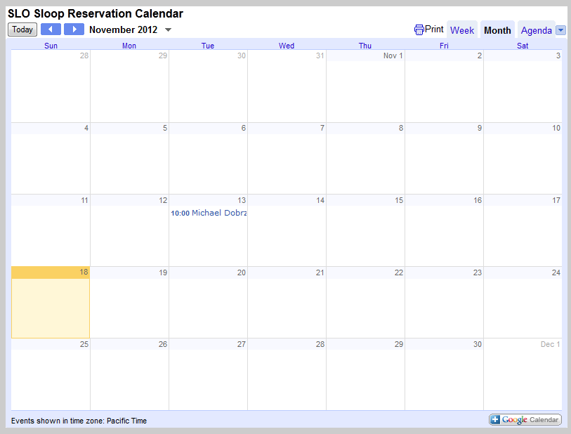
Figure 1

- Click on , located in bottom right of calendar and you will be taken to the Sign-in screen
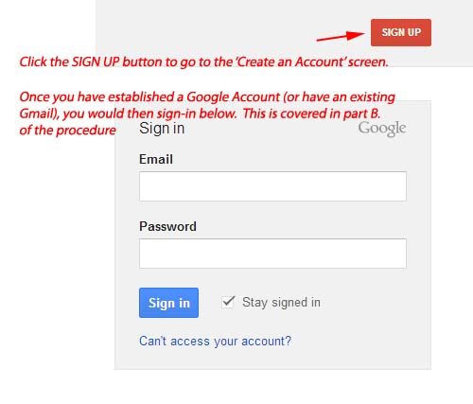

- After selecting 'Sign up', the following 'Create an Account' screen will appear. [see Figure 2] This form is fairly self explanatory. Basically, you are entering an existing email (the one you will use as the user id when signing into the google calendar), and a password (not the same one for your email account). Once you complete this process, you are ready to sign into the SLO Sloop Reservation Calendar.
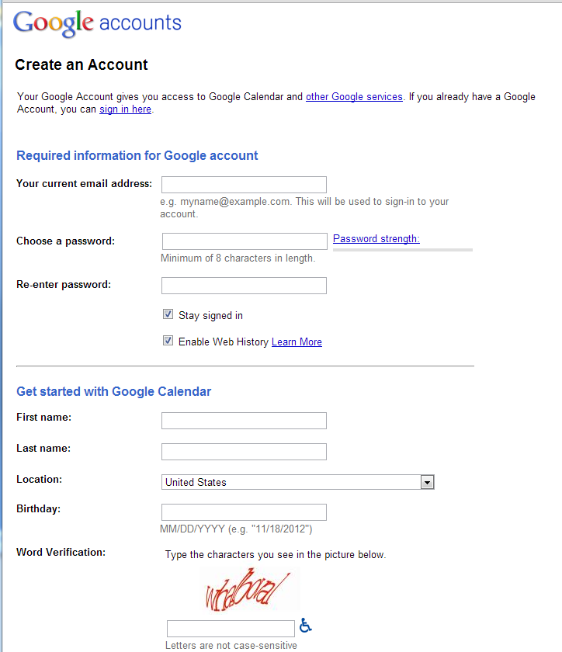
Figure 2

top
B. Sign-in to the Google Calendar to make entries

- First, if this is your first time, notify the webmaster which email account you will be using to log into the calendar so permissions may be setup to allow you to login.
- Navigate to the SLO Sloop Reservation Calendar, located at the bottom of the homepage, above the weather app:
- Click on , (Bottom right of calendar) to log into the SLO Sloop Reservation Calendar. You will be taken to the sign-in screen (Figure 3)

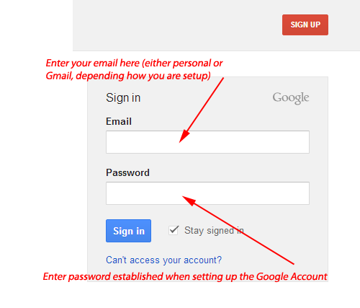
Figure 3

- After sign-in, you will be taken to an editable version of SLO Sloop Reservation Calendar, which will look very similar to the online calendar.
top

C. Making entries in the calendar

- Click into a Blank area in the desired date field, NOT in an existing entry. See (Figure 4)
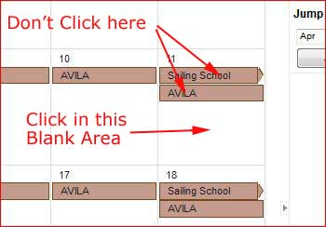
Figure 4
Figures 5 & 6 (respectively) show what the screen will look like when you click in 'Sailing School' or when you click in a BLANK area.

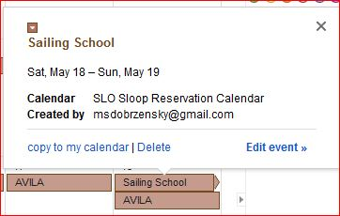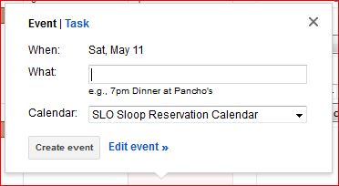
Figure 5 Figure 6
  - Click on the drop down for the calendar (arrow 1, Figure 7) to select the SLO Sloop Reservation Calendar. In the example, Michael Dobrzensky Calendar came up initially. If this is not changed to the SLO Sloop Calendar, then the data entered will go into another calendar.
  - Once we have selected the correct calendar, select Edit event (arrow 2, Figure 7), which will take you to the entry screen.
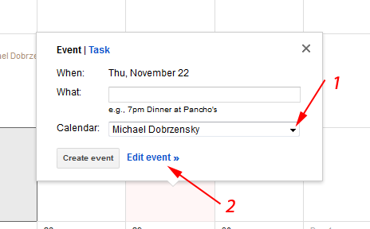
Figure 7

- Clicking on Edit event (in figure 7) brings up the following entry screen: [see Figure 8]
  - Enter your name (person reserving boat) in the Untitled event box
  - Verify correct date
  - Verify correct calendar
  - Enter comments, if you wish..
  - When completed, select SAVE – and you will be returned to the calendar. Make sure the name entered is in the date desired.
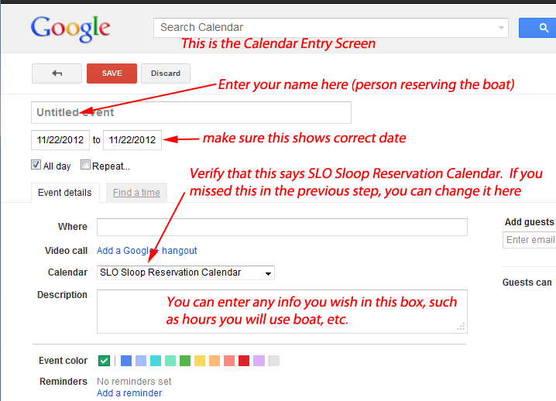
Figure 8

top

