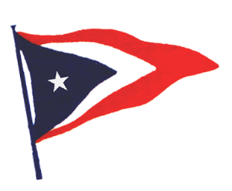
San Luis Yacht Club
2021 Sponsorship Form
Applicant:___________________________________Spouse:___________________________________
Sponsor:___________________________________________________________________________________
Sponsor Phone:________________________Evening:_________________________E-mail:____________________________________
Our all-volunteer club membership is limited to 200 Flag memberships and is often full. Members should be very thoughtful about sponsoring people to become members since few new membership openings are available each year. Consider that, as an all volunteer club, expectations are high that each new member will actively participate in club activities.
From your personal experience, please indicate what recreational boating and other maritime activities the applicant has been engaged in:

Why do you think this applicant would be a benefit to the SLYC?

How long have you known the applicant and in what capacity?

I hereby sponsor the above-named person(s) to become members of the SLYC.

Sponsor Signature:__________________________________________Date_______________
Print Name:_______________________________________________________________________

