Staff Commodore Dinner Guidance
12-6-2013

Contents:
- Preparation
- Agenda (typical)
- Invitation (typical)
- Commodore Dinner Roster
- Table Arrangement (Typical)

Preparation

- Typically held the third week of January
- Responsibility of Commodore Elect
- Confirm a cook for the third Friday in January.
- Order formal invitations in November.
- Also invite current Commodore, Vice Commodore, & Rear Commodore
- Address envelopes with Staff Commodore address list and update any known information. Some people may be children of belated Commodores.
- Mail invitations just after Christmas so that they do not get mixed up with Christmas cards.
- On the day of the event have a small crew to set up tables (usually with table cloths and centerpieces) based on RSVPs received.
- Have a sign-in roster so you will have a list of names (with commodore date) to facilitate introductions
- Have place cards available so when they arrive they may place them where they wish to sit.
- Make sure microphones are working for anything you or your guests may want to say. You may want a short program or just let people enjoy seeing each other.
- Set Commodore tables with place setting of silverware and glasses.
- Dinner is complimentary for Staff Commodores and their Guests.
- Have servers to serve the Commodores and their guests at the tables. The members attending stand in line for their food.
- In the past, Commodores and their guest have been given a ticket for a free drink at the bar.
- Have a crew to take down.

Agenda
(typical, but your call)
- Welcome
- Thanks (setup, cook, servers, bar hosts, etc)
- Introductions (Staff Commodores and Guests), date they were commodore

Typical Invitation
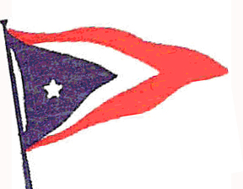
In Honor of Your Service to the
San Luis Yacht Club
You and a Guest are cordially invited to attend the
Commodore’s Dinner
Friday, January 16, 2009
San Luis Yacht Club

RSVP by January 9, 2009  Michael Dobrzensky  Phone (805) 773-1127 | 1800 hours ~ Social Hour  1900 hours ~ Complimentary Dinner

top
Commodore Dinner Roster example
ROSTER SLYC COMMODORES
12-6-2013

*deceased | # honorary member

1937, 1938 Herb McBratney* # (Fran*), 1 Don Antonio Way, Ojai, Ca 93023, (805) 646-4588

1939, 1940, 1941 Harold Puffer * (Mary*) #, 910 St Andrews Dr, Rio Vista, Ca 93571 (707) 374-6358

1942 Paul Wagner (no address)

1943, 1953 Harold Wilkinson* (Jewell)#, 507 Sydnor, Ridgecrest, Ca 93555 (760)446-9792

1944, 1945 Homer Hamlin*(Grace) (no address)

1946,1947 Leonard Lenger* (Ruth)*, 585 Leff St., San Luis Obispo,Ca 93401,543-5465 (son) Leonard Lenger 1203 Carpender Cyn Rd Arroyo Grande, Ca 93420 489-1127

1947,1948 George Duclo # (Rosemary) #,3116 Flora, San Luis Obispo,Ca 93401, 543-1304

1949 Gerard Parsons # (Betty Jo) #, 848 Venable, San Luis Obispo, Ca 93405, 543-9202

1950 Parnell Tilley * ( Betty), 524 N. Lucas, Santa Maria, Ca 93454,
922-5322

1951, 1952 Robert Woolf (No address)

1954 Perry McBeth* (Ramona), 1656 Phillips Ln, San Luis Obispo, Ca 93401 543-6294
Ann McBeth (daughter), 1369 Esro Rd, Fairbanks, AK 99712 907:488-8997

1955 Jerry Bond*(Pat), (No address)

1956 Bob Baldridge* (Clara), 104 Indio Dr, Pismo Beach, Ca 93449, 773-1536

1957 Raymond Schallert (no address)

1958 Ken Jones (Florence), 713 Rancho Dr, San Luis Obispo, Ca 93405, 543-4076

1959 Bill McGrew (no address)

1960 Harlan Perdew* (no address)

1961 Leland Smith* (Joey Wilson daughter), 237 St Andrews Way Santa Maria, Ca 93455, 937-5453

1962 Larry Test* (Liz) P.O. Box 354 Santa Maria, Ca 93456,
937-1354

1963 Bob Stewart* Bob Stewart 1198 Tisha Court Santa Barbara, Ca 93111

1964 Don Law* #(Betty) # 52 Country Club Dr, San Luis Obispo, CA93401, 543-1840

1965, 1967 Delbert Hollinger# (Hilde)# 129 Paddock Ave, Shell Beach 93449, 773-2159

1966 Del Snow-(no address)

1968 Ed Strasser (no address)

1969 Bob Rhodus (no address)

1970 Harold Puffer*# (Mary)*#, 910 St Andrews Dr, Rio Vista, Ca 94571 707 374-6358

1971 Phillip Watkins* # (Carolyn)#, 204 Indio Dr, Pismo Beach, Ca 93449, 773-2336

1972, 1973 Jerry Bowser* (Jean) no address

1974 Gunther Mayer-Harnisch #(Annelie), 1201 Old Oak Park Rd, Arroyo Grande, Ca 93420 489-4172

1975 Neil Moir, 1232 Coral, San Luis Obispo, Ca 93401, 544-2765

1976 Ed Cairns (no address)

1977 Dennis Wheeler # (Daphne*) #, PO Box 2123 Avila Beach, Ca 93424

1978 Al Censullo (Maggie), 1595 Cordova Dr, San Luis Obispo, Ca 93405, 541-0636

1979 Tim Wingard (no address)

1980 Val Gillespie (Sandy), 52 Country Club Dr, San Luis Obispo, Ca 93401, 541-4868

1981, 1982 Edward Hendy* ( daughter Kea McKee PO Box 226, Morro Bay, CA 93443 772-1882

1983, 1984 Chris Schroeder (Linda), 2350 22nd St Oceano, Ca 93445
481-9525

1985 Larry Steffen (Claire), 31 Bayview Rd, Castroville, Ca 95012, 633-2274

1986 Jeff Liberman, 304 Windward Ave, Shell Beach, Ca 93449, 773-1789

1987 Kirk Miller, (Mary), 405 Indio Dr, shell Beach, Ca 93449, 773-5512

1988 Jim Robinson*, (Deborah) 3140 Estellita Ct SLO, Ca 93401, 544-4230

1989 Darrel Rundstrom# (Linda)#, 789 Manauela Way, Arroyo Grande, Ca 93420, 489-0742

1990 Ray Belknap (Pat), 70Benton Way, San Luis Obispo, CA 93405. 541-2080

1991 Dave Lampert, 2475 Appaloosa Way, Arroyo Grande, Ca 93420, 489-4832

1992 Charlie Nichols (Lisa), 2171 Almond Springs Dr , Ca 93446, 489-7551

1993 Jim Henry (Marilyn), 2333 Estbury Way Santa Maria, Ca 93455

1994 Bryon Briley (Jenny) 942 Valecito Ct San Luis Obispo, Ca 93405, 783-1407

1995 Candace Calder (Bill), P.O.Box 1086, Arroyo Grande, CA 93420, 489-6213

1996 Jay Chapel (Judy), 164 Baker Ave, Shell Beach, Ca 93449, 773-2865

1997 Bill Hart (Ruth), 3335 S El Pomar Rd, Templeton, Ca 93465, 434-2949

1998 Patrick Mc Gowen, 1140 Refugio St. Grover Beach, 93433,
473-1446

1999 John Katavich , 3383 Katacreek Rd, Creston, Ca 93432,
438-5833

2000 Rob Bollay (Ann), 320 Squire Canyon Rd, San Luis Obispo, Ca 93401, 595-2722

2001 Karen Gruber, PO Box 165, Avila Beach, Ca 93424, 595-7469

2002 Richard Cassera (Donna), 16405 Walnut Ave Atascadero, Ca 93422

2003 Pam Katavich, PO Box 272, Santa Margarita, CA 93453
438-4283

2004 Ed Smith (Mary) Po Box 2510 Avila Beach, CA 93424 595-9440

2005 Karen Hiatt (John) 126 Valley View Dr Pismo Beach, Ca 93449
773-8268

2006 Brian King PO Box 2196 Avila Beach, Ca 93424 235-7361

2007 Mark Machala (Christine) 130 So Mesa Road, Nipomo, Ca 93444 805 929-6570

2008 Dorie Zwinger (Tom) 125 Pioneer Circle Arroyo Grande, Ca. 93420 805 474-4125

2009 Michael Dobrzensky (Carol) 1604 Costa Brava, Pismo Beach, Ca 93449 805 773-1127

2010 Steve Davis P.O. Box 4137, San Luis Obispo, Ca 93403

2011 Bob Hurd (Marjorie) 1748 Deer Canyon Rd, Arroyo Grande, Ca 93420

2012 Warren Ristow (Melenie) P.O. Box 70, Creston, Ca 93432

2013 Bill Dyer (Jean) 531 Ocean View Ave, Grover Beach, CA 93433

Updated 12/6/2013

Typical Table Arrangement
Commodore – Vice Commodore – Rear Commodore at head table
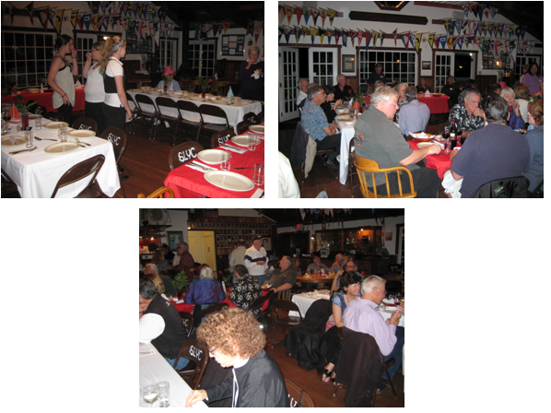
top

